Tristyn Horrell  
ID: 2152956  
  
Using predictive data analytics to increase sales and manage supply/demand in an e-commerce system  
  
BSc Information Technology  
Undergraduate Thesis Report  
  
Department of Computer Science & Technology  
University of Bedfordshire  
  
Supervisor: Ravi Ragoonath  
22/23

# Abstract

Used auto-parts and scrap iron are implicitly embedded into the economy of countries like Trinidad and Tobago wherein it is cheaper and quicker to refurbish or refabricate used parts and metal than to import them using foreign exchange. Despite this, the means by which they are bought and sold are primitive, usually through passing vehicles pre-loaded with goods and cash which may represent a hazard to the salesman. The aim of this study is to relocate this storefront from a roving flatbed to a convenient online e-commerce platform wherein users can more easily list prices for goods on hand and browse parts and metal on offer from other workshops. The success of such a platform may directly correlate to a minimization of noise pollution in countries like Trinidad where the marketing for said parts is usually done over a megaphone attached to the vehicle which can be disruptive to residents in the area.

The methods that will be used to gather the requirements of the system will be in the review of similar online storefronts and e-commerce websites. This shall be used in tandem with secondary research, using a variety of peer-reviewed sources to extrapolate on the analysis of the literature review.

Analytics at the end of the day is crucial in the success of any thriving business, and the opportunity to reflect on the various statistics that comprise a typical auto shop or scrapyard can be key in bolstering the success of these local businesses. If a quantity can be assigned to a successfully selling particular part or seasonal spending habits can be studied to more meaningfully engage buyers at the right times of year to ensure maximised profits for one’s entrepreneurial endeavours.

At the end of this project, it is expected that the Online Used Parts and Scrap Store will be able to resolve the problems currently experienced by mechanics and metal workers while also providing a more comprehensive listing of products and prices to consumers. Through accruing data by these transactions, we can also determine the auto parts and metals most in-demand and can hence wholesale local suppliers can make better marketing decisions with respect to importing new versions of said product. This paper concludes with a discussion of results, findings and objectives completed and finally an evaluation of the entire project, including an appraisal of methodologies used, project planning skills and an assessment of the artefact itself.

# Acknowledgement

I would like to extend my gratitude to the University of Bedfordshire for their much required resources such as Office 365, as well as access to platforms such as Emerald Journals which were invaluable in the research process and hence the successful completion of this project and report.

I would also like to thank my project supervisor, Mr. Ravi Ragoonath for his unwavering dedication to the success of his students and steadfast resolve in ensuring they have the best tools, advice and direction at their disposal to see the project to fruition. I would also like to thank Mr. Marcus Alexander whose coding acumen and brilliant teaching has granted me the technological wizardry necessary to complete such a complex product. My gratitude goes out to Mr. Aaron Narace as well, whose constant check-ins and around the clock availability proved essential to not only my completion of the project but my motivation throughout.

# Dedication

I would like to dedicate this project to my hard-working parents Mr. Darren Horrell and Mrs. Lisa Lakhan-Horrell, whose continued love and support have made the completion of this project possible. The collective riches in the world would not be enough to repay them for their dedication to not only my future but that of the population of Trinidad and Tobago. I would also like to thank my brother Aidyn Horrell for motivating me, as well as my puppy Rogue for lifting my spirits on the days when I need it most.  
 I would also like to extend thanks to my mentors, Denis Scott and Scott Taylor, whose guidance and belief in me have gotten me to where I am today. Everyone needs someone who can pick them up after a particularly nasty fall, and there are none better at it than these two.

Finally I would like to thank God, who grants me the strength to achieve anything I set my mind to, and through Whom I know all things are possible.

# Keywords

* E-Commerce
* Gamification
* Analytics
* Data
* User Experience
* Auto-parts
* Scrap Iron
* Online Retailing

**Abstract** **2**

**Acknowledgement** **3**

**Dedication** **4**

**Keywords** **5**

**CHAPTER 1: Introduction** **9**

1.2 Subject 9

1.3 Project Aim 10

1.4 Project Objectives 10

1.5 Summary of Chapters 11

**CHAPTER 2: Project Management** **14**

2.1 Introduction 14

2.2 The Importance of Project Management 14

2.3 Work Breakdown Structure (WBS) 14

2.4 The Gantt Chart 16

**CHAPTER 3: BACKGROUND RESEARCH** **18**

3.1 Introduction: 18

Literature Review 18

Introduction 18

3.2 E-Commerce Discussion 19

3.3 Website Review 20

3.4 The Principles - Ecommerce Functionalities 20

Recommender Systems 20

Encryption 25

Responsive Design 27

3.5 Project Related Choices 30

Software Development Tools 31

Software Development Approach 32

3.6 Summary 33

3.7 Recommendations 34

**CHAPTER 4: REQUIREMENTS ANALYSIS** **35**

4.1 Introduction 35

4.2 The Process of Producing the Requirements 35

4.3 Personas 35

4.4 The Requirements 38

4.5 Non Functional Requirements 40

4.6 Use Cases 44

4.7 Information Architecture 44

4.8 Activity Diagrams 45

**CHAPTER 5: DESIGN** **46**

5.1 Introduction 46

5.2 Database Design (Back End Design) 46

5.2.1 ERD 46

5.2.2 Normalisation Process 47

5.2.3 Logical Model 47

5.2.4 Data Dictionary 49

5.3 Application Design (Front End Design) 50

5.3.1 Nielsen’s Heuristics 50

5.3.2 Sketches 51

5.3.3 Wireframes 52

5.3.4 Interactive Prototype 56

**CHAPTER 6: IMPLEMENTATION** **59**

6.1 Introduction 59

6.2 Database Implementation 60

6.2.1 Database Amendments 65

6.3 Connection between Database and Front End 66

6.4 User Interface Implementation 67

6.4.1 Core Features Implemented 67

6.4.2 Advanced Features Implemented 73

6.5 Security Consideration 75

6.6 Error Messages 76

6.9 Version Control 81

6.10 Features Not Implemented 82

**CHAPTER 7: TESTING** **83**

7.1 Introduction 83

7.2 Test Plan 83

7.3 Functionality Testing 83

7.4 Non-Functionality Testing 87

7.5 Defects Log 90

7.6 Analysis of Test Results 90

**CHAPTER 8: EVALUATION** **91**

8.1 Introduction 91

8.2 Method of Evaluation 91

8.3 The Heuristics 91

8.4 Summary of Findings 96

8.5 Analysis of Results 96

**CHAPTER 9: CONCLUSION** **97**

9.1 Introduction 97

9.2 Tasks Completed 97

The Project Plan 97

The Artefact 98

The Project Progress Reports 99

9.3 Experiences Gained 100

9.4 Product Built 101

**10 References** **102**

**Appendices** **107**

Appendix A: Meeting Log with Supervisor and Progress Reports 107

APPENDIX B: Functional Requirements - Core and Advanced 120

APPENDIX C: Additional Wireframes 133

APPENDIX D: Chatbot Models 134

APPENDIX E: Comparing Agile and Waterfall Methodologies 135

APPENDIX F: Programming Language Comparison 136

APPENDIX G: Poster 137

# CHAPTER 1: Introduction

The purpose of the Introductory chapter is to briefly describe what the project is about by defining the scope of the project and the background idea for the project. It will also examine the problem area and serve as a roadmap for the rest of the report.

## 1.2 Subject

Used auto-parts and scrap iron are implicitly embedded into the economy of countries like Trinidad and Tobago wherein it is cheaper and quicker to refurbish or refabricate used parts and metal than to import them using foreign exchange. Despite this, the means by which they are bought and sold are primitive, usually through passing vehicles pre-loaded with goods and cash which may represent a hazard to the salesman. The aim of this study is to relocate this storefront from a roving flatbed to a convenient online e-commerce platform wherein users can more easily list prices for goods on hand and browse parts and metal on offer from other workshops. The success of such a platform may directly correlate to a minimization of noise pollution in countries like Trinidad where the marketing for said parts is usually done over a megaphone attached to the vehicle which can be disruptive to residents in the area.

The methods that will be used to gather the requirements of the system will be in the review of similar online storefronts and e-commerce websites. This shall be used in tandem with secondary research, using a variety of peer-reviewed sources to extrapolate on the analysis of the literature review.

Analytics at the end of the day is crucial in the success of any thriving business, and the opportunity to reflect on the various statistics that comprise a typical auto shop or scrapyard can be key in bolstering the success of these local businesses. If a quantity can be assigned to a successfully selling particular part or seasonal spending habits can be studied to more meaningfully engage buyers at the right times of year to ensure maximum profits for one’s entrepreneurial endeavours.

At the end of this project, it is expected that the Online Used Parts and Scrap Store will be able to resolve the problems currently experienced by mechanics and metal workers while also providing a more comprehensive listing of products and prices to consumers. Through accruing data by these transactions, we can also determine the auto parts and metals most in-demand and can hence wholesale local suppliers can make better marketing decisions with respect to importing new versions of said product. This paper concludes with a discussion of results, findings and objectives completed and finally an evaluation of the entire project, including an appraisal of methodologies used, project planning skills and an assessment of the artefact itself.

## 1.3 Project Aim

This project focuses on the analysis, design, implementation and evaluation of an online e-commerce platform for scrap metal and used auto-parts by using predictive data analytics to increase sales and manage supply/demand in an e-commerce system.

## 1.4 Project Objectives

The Aim can be achieved incrementally by the totality of objectives which the student must carry out to complete the project. When setting goals it is generally wise to adhere to making them SMART goals or Specific, Measurable, Achievable, Relevant, and Timely – and that they should be in the right order of execution.

The objectives of the project are:

1) Conduct background research and literature review using secondary data from published authoritative sources on the current state of the art in the area of the proposed project to assist in directing the path of the project by Week 1 of Semester 2.

2) Complete the requirements analysis by developing a full list of functional and non-functional requirements of the intended system, to avoid ambiguities about what the requirement is intended to do, by Week 2 of Semester 2.

3) Design the application with the use of low fidelity prototype for the front-end and an entity-relationship diagram for the database back-end to ensure that the system can accommodate all the requirements, by Week 3 of Semester 2

4) Implement the functions of the software by using a suitable language in programming to ensure the project delivers its intended features, by Week 9 of semester 2.

5) To test the application by developing a detailed test plan using test data to ensure the application works the way it is intended to, by Week 10 of Semester 2.

6) Evaluate how usable the application is by means of heuristic evaluation to determine how well the software executes its expected objectives by Week 11 of Semester 2.

7) Compile final report using Google Docs/MS Word which will include objectives that were stated previously as individual chapters to document the student’s progress, by Week 12 of Semester 2.

## 1.5 Summary of Chapters

The following is a brief summary of the content of each of the succeeding chapters of the final report, starting with Chapter 2 (Project Management) and ending with Chapter 9 (Conclusion)

**Chapter 2: Project Management**

Dawson (2017) suggests that without a plan in place, one would lose direction and would have little sight of where they are going and will not complete the project on time. This chapter focuses on the project management aspects of the project and will look at the importance of project management while utilising techniques such as a work breakdown structure and a Gantt Chart to assist in the overall management of the project.

**Chapter 3: Background Research**

Background research involves investigating other persons’ work in order to get more information that you may use in your project. For example, if you are building an ecommerce website, you may want to look at Amazon.com to learn more about the features of an ecommerce website.

Therefore, using Amazon.com, you may come up with several features (which in this project we will call “The Requirements”). These include signing up for an account, login, search, view products details, add products to cart etc.

However, the background research is not limited to finding only the requirements for the project, but it is also the investigative work that would help you to learn more about the software you may use to build the application, learning about designing user interfaces, about how to make your website credible (trustworthy), about the choice of software development methodology, about version control etc.

**Chapter 4: Requirements Analysis**

Chakraborty et al. (2012) consider requirements analysis to be the most crucial step of the systems development life cycle (SDLC) since it creates a collection of precise, unambiguous requirements that will be employed in later phases of the project and serve as the foundation for the creation of the system.This aspect of the project will include the approaches used to gather the requirements, and the output will include a list of these functional and non-functional requirements. These will be used along with a series of documents that capture the requirements such as use case diagrams and activity diagrams.

**Chapter 5: Design**

A poorly designed website can affect an organisation in many negative ways, while a professional site will encourage visitors and inspire confidence in their customer base. Avoiding the damage that can be inflicted on your organisation by poor website design is necessary to compete successfully in today’s competitive environment. The design phase of the application will look at the design decisions that will be considered in development of the software artefact. It will also look at the design of the database required to store the data as well as the design of the user interface. It also includes consideration of HCI issues and how they will

influence the design.

**Chapter 6: Software Implementation**

This implementation phase is the most crucial phase in the development of the software artefact, for without this phase, there will be no artefact. The development of the e-commerce website for the online scrap metal and used car parts business is the focus of this stage of the artefact planning process. It emphasises the actual tasks completed, such as setting up the software tools and getting the database and application to "speak" to one another. It also involves creating the database tables and writing appropriate programs to have the website completed.

Various aspects/features associated with the Implementation Phase include:

● The Development Environment

● Creation of Database

● Connection between Back End and Front End

● User Interface Implementation (such as)

● Responsive Design

● Gamification Technique

● Recommender System

● Changes made to the original Designs

● Handling of Error Messages

● Implementation of Security Features

● Implementation of Version Control

**Chapter 7: Testing**

The purpose of testing is to make certain that the implemented system is working correctly

and efficiently. Testing can give confidence in the quality of the software if it finds few or

no defects. A properly designed test that passes, reduces the overall level of risk in a

system. When testing does find defects, the quality of the software system increases when these defects are fixed.

This phase of the artefact development covers the testing of the functional and

non-functional requirements of the system. A test plan will be used to indicate each test

being done including data (normal, extreme and abnormal data) to be used where possible.

Testing will include black box and white box testing as well as unit testing and integration

testing. The results will be recorded in the test document. Defects found will be recorded

in a defects log, which will be used as the source for bug fixes at the end of testing.

**Chapter 8: Software Evaluation**

Evaluation is a vital step in the software development process. Releasing applications that

contain usability flaws, which will cause more angry users and support line calls.

as well as customers that stop using your product. The evaluation strategy ensures that this

forethought about the users’ needs and goals will not be accurate. Most assessments have the general objective of giving "valuable input" to a range of audiences that may include stakeholders, staff, administration, client-groups, donors and sponsors. In this case, the academic team at UoB. This phase is not about whether the application works - this was answered by results of testing but “how well does it work?” (“how usable is it?”). This phase focuses on evaluating the usability of the application through the use of a heuristic evaluation.

**Chapter 9: Conclusion**

The right strategy, together with appropriate planning, task tracking, and scheduling, is essential to ensuring a successful outcome. In order to guarantee adequate project management is used throughout the project life cycle, a work breakdown structure and project plan were created. An artefact is necessary for the project to be finished, hence an artefact plan was made. This involved locating, evaluating, and summarising pertinent methods required to validate the design as well as pertinent hardware, software, or simulation tools that will be used to analyse the design. Since the project will be completed quickly and with few resources, agile technique will be used. The technique will cover all phases of the systems development life cycle, including background research, compiling a comprehensive set of requirements, designing and creating the artefact, testing it, and evaluating it.

The student was required to take on a challenging solo project; This was an academic project that involved writing a sizable technical dissertation as well as producing a useful artefact. The final chapter of the project is a culmination of the work done and the experiences gained during the project development. This chapter shows my accomplishments and what, if given the chance, I would do differently. The software artefact is also viewed critically in this chapter.

# CHAPTER 2: Project Management

## 2.1 Introduction

Planning is crucial in regards to keeping on schedule and ensuring that necessary project objectives are met in a timely manner and that sufficient energy is expended accordingly to each objective. This chapter examines the critical nature of project management and the importance of the techniques employed. These techniques include the use of a Gantt Chart, as well as a Work Breakdown Structure.

## 2.2 The Importance of Project Management

One may clearly comprehend the relationship between crucial dates, project activities, and the amount of time required for each activity with the help of effective project planning. Future issues, including missing deadlines, are made easier to avoid. This aides in the comfort with which a large project like this can be completed, by incrementing the larger more daunting aspects of the project into more manageable time-frames, allowing for better compartmentalization of effort and time expended per section.

This unit has several project deliverables that are due over a 13 week period.There are consequences for submitting these deliverables late because they are assignment-based. Along with these, the endeavour necessitates mastery of a wide range of technical skills, including academic writing and programming. To ensure the project is successfully completed on time and with a high level of quality, it is crucial that one employs some form of project management.

There are several tools that can be used to manage a project successfully; in this case one would employ the use of the Work Breakdown Structure (WBS) and the Gantt Chart. The WBS would identify the tasks and subtasks while the Gantt Chart would reflect these tasks using start and end dates, and would also track the percentage completion to assist in determining if the student is on track, ahead of, or behind schedule.

## 2.3 Work Breakdown Structure (WBS)

A work breakdown structure lists all the objectives for a project, organises them into tiers, and displays them graphically. This is important as it breaks up larger, more complicated tasks into simpler, easier to accomplish subtasks. This simplifies the project management process and makes it easier to estimate the time taken to complete larger tasks. The first step in creating the WBS for this project was identifying the high-level tasks - these equated to the project deliverables which were obtained from the Project Handbook.

The six main objectives identified in the Future Plans section, once completed, would imply a successful project. Four of these objectives were further broken down into lower levels of details. The first objective, the Reflective Report was further broken down into two tasks (Self Reflection and List of Chapters of the Final Report). The software Artefact was also further decomposed into development of the core features and the advanced features. Figure 1 below shows the WBS for the Undergraduate Project.

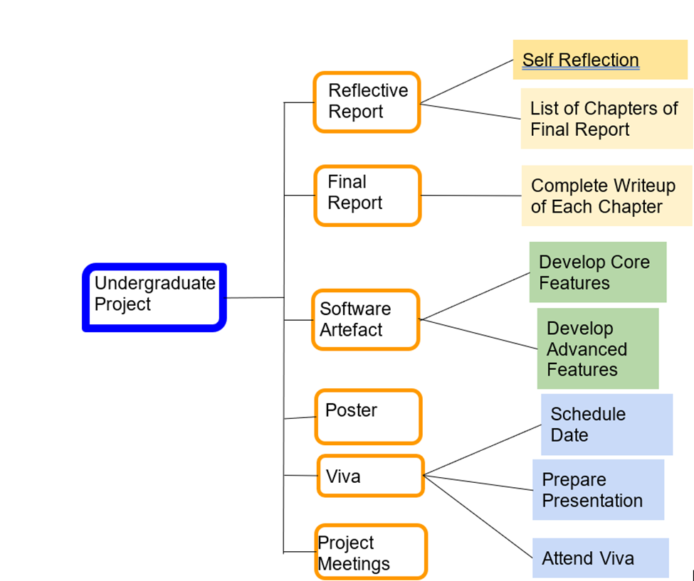

*Figure 1: Work Breakdown Structure*

## 2.4 The Gantt Chart

The Gantt Chart provides a visual view of the tasks scheduled against time and is considered one of the best techniques used in Project Management. Planning and scheduling projects are the primary use of a Gantt Chart of this nature. They help assess how long a project should take, determine the resources needed, and plan the order in which the tasks should be completed. They are also helpful for managing the dependencies between tasks.

The first step in creating the Gantt Chart was identifying the tasks and subtasks. The WBS was useful in this regard as it provided the full list of tasks and subtasks. Additionally, some of the tasks in the WBS (such as the Final Report), were further broken down into its individual chapters when developing the Gant chart.

Given the role of the Gantt Chart is to assist in determining the scope and feasibility of the project and to estimate how long each activity will take, and how much time should be spent on any given task - appropriate columns were included. For each task, a start date, end date and duration columns were added to assist in determining how long each activity will take and how much time should be spent on each task. A predecessor task column was added to help in ordering the tasks and managing the dependencies among them. In order to actively manage the project a “% Completed” column was added to track how much each task has been completed. This also provided an early opportunity to discover if any task might have been forgotten or recognised at a later stage of the project and served as a basis for scheduling activities and monitoring the project’s progress.

As with any project, things can go wrong. As such the Gantt chart must include elements of risk management to ensure that there is sufficient buffer included in case any unforeseen circumstances occurred (Dawson, 2017). As such, most of the deliverables had a due date of at least one week earlier than the scheduled deadline to cater for such challenges. To develop the Gantt chart, Microsoft Excel was utilised. Excel also had several templates for creating the Gantt chart and these were easy to use and easy to adjust. See Figure 2 below for a copy of the Gantt chart for the Undergraduate Project.

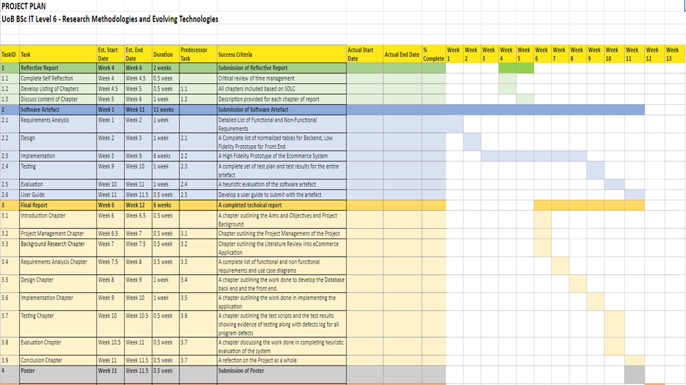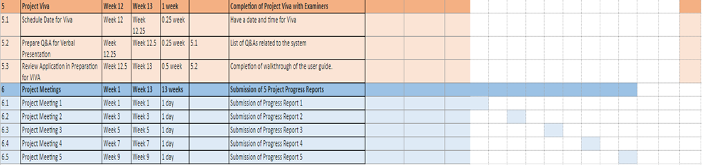

*Figure 2: GANTT Chart of Project Plan*

# CHAPTER 3: BACKGROUND RESEARCH

## 3.1 Introduction:

The contextual report is an advancement of the work done in the Project Proposal (Assignment 1) through the completion of a detailed **literature review** on work done in the area of the project, while also preparing the student to undertake the project by developing a detailed **project plan** along with a **plan for the development of the artefact.**

**Literature Review** - The purpose of this segment is to critically compare and analyse research papers as well as professional web articles and journals within the scope of the subject matter. By doing so a comparison can be made between the relevant technologies included within these papers and journals. The literature review will look at development, tools, approaches as well as algorithms in the chosen area of the project subject.

**Project Planning** -The project plan is used to create a structural method of how the project should be completed. By breaking down the project into tasks it will make the execution of the project easier, and setting deadlines for crucial elements is an effective way of placing priorities across tasks. A Gantt chart is used as the base of the project plan, this is created to visually plan every step of the project. Adhering to a plan is necessary and failing to do so could result in problems further ahead. If deadlines are not met then eventually there may come a point when work is being rushed to meet the ultimate deadline, which can cause the quality of work to dramatically deteriorate as a consequence.

**Artefact Planning** - The last chapter of the Contextual Review contains the planning of the artefact. Before the creation of an artefact, a thorough plan must be drawn up to ensure all requirements and specifications are in place before implementing the artefact. A suitable methodology is used as a guideline when designing, implementing and testing the artefact.

### 

### **Literature Review**

### **Introduction**

The Literature Review is essential for comprehending the problem domain; it includes aspects of the project that need investigation, discussion, analysis, and evaluation. It will be used to guide the project's future stages, such as the design and implementation phases. A collection of previously related research projects by other people, the majority of which were peer-reviewed sources, is accessed as part of the literature review.

According to Rowley and Slack (2004) a summary of the body of research in a topic that enables the formulation of particular research questions is known as a literature review. A literature review must consult and assess a wide variety of sources, including books, articles from scholarly and professional journals, and web-based resources. The identification and location of pertinent documents and other sources are made easier with the aid of the literature search.

This section will concentrate on the topic of e-commerce and explore some of the important components of it, such as gamification and recommender systems. It will also contain a literature evaluation of several project-related decisions, such as the selection of software tools and development methodologies.

## 3.2 E-Commerce Discussion

There has been a considerable shift in the spending habits of the population as a whole when it comes to where our shopping is done. Over the last few years, with the advent and improvement of mobile technology - it has become easier than ever to browse and purchase products through online storefronts as opposed to in-person retail outlets. This gravitational shift, in addition to being spurred on by convenience and security, was exacerbated by the Covid pandemic, wherein the population was spearheaded in the direction of avoiding real-life commerce habits and instead doing their shopping via online storefronts. Gavrila and Ancillo (2021) argue that the pandemic was found to be an accelerator regarding both consumers' habits and organizations' innovation and digital transformation, breaking with the past leading to new sustainable growth business models.

There is a multiplicity of advantages offered to a prospective consumer or business-owner when considering the e-commerce route. As described by Prasanna (2022) these include: a larger market and outreach to potential customers, consumer insights via tracking and analytics, fast response to the consumer trends and the market demands, more opportunities for selling and wide berths of information on a given product, personalised messaging alongside custom customer profiles, increased bulk sales with instant gratification, and the ability to quickly and easily scale up or down given infinite shelf-space.

However, Prasanna (2022) goes on to detail the varied disadvantages posed by ecommerce as well such as: lack of personal touch, lack of tactile experience, intense product and pricing competition due to comparative spending, necessity of internet access with reliable connection, credit card fraud, Information Technology security concerns, loss of revenue if a business exclusively sells online and there is technical difficulties, as well as complexities in the regulation, taxation and legislative compliance in given regions. Also, one cannot assess the product in person before making the purchasing decision, and buying online typically includes lengthy waits for delivery time. Like any component of technology there are benefits and drawbacks, nevertheless the data shows that ecommerce is not only here to stay, but is a burgeoning and growing economy. Some trends that can be charted include online purchasing becoming more realistic thanks to AR, voice search increasing in frequency, AI assisting retailers in learning about their customers, on-site customisation to produce distinctive experiences, chatbots making shopping more enjoyable, shopping on the go gaining prevalence, more payment options etc.

It is key to note the emerging technologies in these cases, as they are reflective of the intended features of the project at hand. Customization built on a customer’s profile is crucial to the intended purpose of the project at hand, as retargeting in order to increase sales is the focus of the platform planned. AI chatbots are a goal to be implemented in the project, not only for how useful they are to customers but for the benefit they can provide in the authenticity of a platform. Payment options such as Stripe are also intriguing as they offer another payment route from traditional cash transferals, and hence will be explored in the project as well.

ECommerce solutions to typical spending patterns hence are receiving increasing attention in the academic literature and is an essential component of some of the world's largest web sites (for example, Airbnb, Alibaba, Amazon, eBay, Facebook, Flipkart, Lowe's, Taobao, and Target) (Kallumadi et al., 2021) As a result, the successful development of an artefact of that nature involves examination of these pre-existing entities and drawing upon the components of them that make them work.

### 

### 

## 3.3 Website Review

As mentioned above, these are some of the most popular websites in the designated project area:

1. Amazon.com - World’s largest online retailer
2. Alibaba.com - Eastern market’s version of Amazon
3. eBay.com - purveyor of used goods and second-hand purchases, which is parallel to the chosen stock to be sold on the project website
4. Facebook.com/marketplace - The social media giant’s version of user-bought and sold goods and services

There is a pervasive through-line that all of these platforms share in terms of features, which one would surmise contribute toward their resounding success. These features include but are not limited to:

● Ecommerce Analytics

● Gamification

● Online Payment methods

● Recommender Systems

● Responsive Design

● Advanced Searches

● Chatbot Functionality

As a result, it would be prudent to include these features in the designated project as well, if one were to emulate the success of these existing websites. This literature review will primarily focus on gaining a better understanding of these functions so that they can be optimally implemented into the final artefact. Additionally the literature review will include a comparative analysis of the software tools and development methodology related to the project.

### 

## **3.4 The Principles - Ecommerce Functionalities**

### **Recommender Systems**

According to Schafer (1999), a recommender system learns from a customer and recommends products that he/she will find most valuable from among the available products. This comes as a form of targeted advertisement, as customers are primarily recommended products they as an individual are more likely to purchase, which will effectively drive up sales.

Generally speaking, Recommender systems use formulaic and algorithmic methods like Page Rank, while others employ methods that are more model-centric, such as collaborative filtering, content-based methods, link prediction, et cetera. The complexity of each of these methods can vary, but complexity does not equate to "good" performance. Simple strategies and tactics frequently produce the best outcomes. For instance, major corporations like Reddit, Hacker News, and Google have promoted content on their platforms using straightforward, formulaic implementations of recommendation engines (Vatsal, 2022).

The dataset and strategy used to generate the recommendation have the only bearing on how it is evaluated. There are many conceptual connections between recommender systems and the classification and regression modelling issue. The only factors affecting the recommendation's evaluation are the dataset and generation method. Recommender systems and the problem of categorization and regression modelling have many conceptual connections.

By analyzing the preferences and data from numerous users, collaborative filtering predicts a user's interests. This is accomplished by applying approaches involving cooperation among numerous agents, data sources, etc. to filter data for information or patterns. Collaborative filtering is based on the premise that customers A and B are likely to have similar tastes in other products if they have similar tastes in one product. The biggest drawback of this approach is that there hasn't been any user-item interaction with it, which makes it unfriendly for making recommendations for new goods. The term "cold start problem" is used to describe this. On extremely sparse datasets, memory-based techniques are known to perform badly.

Recommendations are generated by content-based systems based on the preferences and profile of the user. They strive to match customers with products that they have previously loved. The characteristics of products that the user likes serve as a general basis for determining the degree of similarity between items. There are two fundamental drawbacks of content-based systems:

1. Based on the items or content the user has consumed, the recommendations are "obvious". This has the drawback of never recommending a certain sort of item to the user if they have never interacted with that item. This detracts from recommendation diversity which is bad for business

2. They are useless for making suggestions to new users. A history of explicit or implicit user-level data about the objects is necessary for developing a model. A large ratings dataset is typically necessary to produce reliable predictions without overfitting.

Each type of recommendation system has advantages and disadvantages. When applied alone, several of these techniques can appear to be limiting, especially when there are numerous data sources available for the problem. Hybrid recommender systems are those created to produce reliable inferences from a variety of available data sources.

Parallel and sequential designs are the two most common types in hybrid recommendation systems. A single output is produced by combining the recommendations from each of the numerous recommendation systems that are fed data from the parallel design. A single recommendation engine receives the input parameters from the sequential design, and the result is sequentially handed on to the next recommender. For a graphic illustration of both designs, see the Figure 3 below.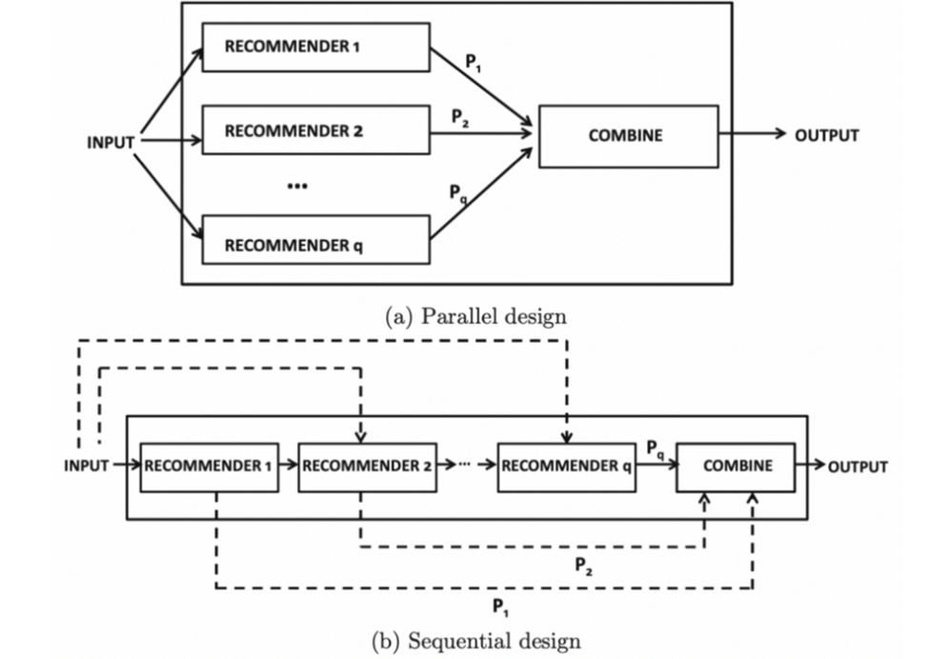*Figure 3: Parallel and Sequential Recommendation System Architecture.*

Source: Recommender Systems: The Textbook (2018)

The computational complexity of these models is typically significant, and they require a sizable database of ratings and other attributes to be kept current. Without current metrics (such as user engagement, ratings, etc.), it is challenging to retrain and offer fresh recommendations based on new items and user ratings.

Examples of companies using Recommender Systems include:

YouTube content recommendation to users — recommending you videos based on other users who have subscribed / watched similar videos as yourself.

CourseEra course recommendation — recommending you courses based on other individuals who have finished existing courses you’ve finished.

Amazon product feed (you’re being recommended products similar to what you’ve previously purchased)

Spotify music recommendations

Netflix generates recommendations to users based on the watch and search style of similar users (collaborative filtering) in conjunction with movies which share similar characteristics who’ve been rated by users (content based).

The Recommender System will be used in this project to acknowledge what types of parts or vehicles a customer is interested in based on his/her site activity/ past purchases. This will then be used to display similar parts or variant models of the same vehicle brand to drive up the possibility of them making a purchase.

**Ecommerce Analytics**

Web analysis can be used to improve ecommerce marketing and advertising, understand customer behavior, increase conversion rates, strengthen loyalty, optimize merchandising and product mix, streamline transactions, optimize product mix, and accurately attribute sales. (Philips, 2016) Any successful business must use data analysis to make informed decisions about the management of the business. Ecommerce offers a unique opportunity to streamline this experience external to typical data acquisition, such as having customers complete surveys or reviews. Given the technological fingerprint left by all devices, there is a lot to be learned from someone who simply visits the site, and even more so by someone who actively engages with it.

This goes deeper than Recommending products to the user, but entails big picture decisions as it applies to marketing, conversion tactics, loyalty programs etc. According to Kaufman et al. (2012) The ability to manage and safeguard data as a strategic asset, transform it into actionable information, and use it as a strategic differentiator is a key contributor to the success of any business operation. What makes this an even more interesting challenge is the speed at which data have been growing in recent years, due to social networking, the Internet, mobile telephony and all kinds of new technologies that create and capture data.

Garcia et al. (2016) have depicted through survey that the majority of analytics happen through Google via Figure 4 below:

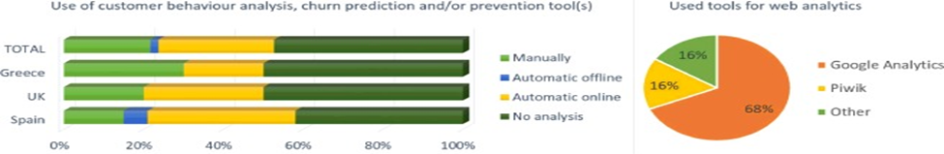*Figure 4: Statistical Findings on the use of Data Analytics in a sample of European Businesses*

Source: Expert Systems with Applications (2016)

It also shows that while a lot of user’s data can be tracked, the majority of it goes untracked, implying there is always more to be learned about the buying patterns of a prospective business’ demographic, if more intensive data aggregation methods were used. This is a limitation of current data analytics, as many businesses default to using Google Analytics instead of higher level analytics like SQL to interface with relational database management system (RDBMS), or for stream processing in a relational data stream management system (RDSMS). Understanding how specific, ambiguous, or broad the intent of a search query is, across all users of the system, is important in improving search relevance in eCommerce. There is scant literature on such a structural characterization of queries in eCommerce (Pradhan, Deolalikar, and Li, 2015). Hence, there will be a focus on use of SQL as opposed to lower-level analysis as it will bolster the amount of data available and thereby increase the amount of actionable information upon which business decisions can be made.

**Gamification**

This principle can be described as the application of values intrinsic to gaming in non-gaming environments to promote the same responses and behaviours in those participants and elicit the same reactions that gaming typically invokes. The literature agrees that the emerging interactive technologies and the increased usage of digital platforms can make the experience more engaging and consumers more loyal with positive effects on retailers' profitability (Rodrigues et al., 2016).

There is a natural human predisposition toward being encouraged by principles implicit in a gaming setting (point scoring, competition, rewards, rules etc.) As a result, commodifying these attributes and applying them to an online storefront has been shown to boost customer engagement, loyalty, brand-recognition and repeat purchases. From a theoretical perspective, gamification is becoming a relevant research topic being a driver for experiential aspects (i.e. enjoyment, engagement and retention) of the user-platform interaction (Hamari, 2013; Hofacker et al., 2016).

Some drawbacks in Gamification may entail a lack of strategic connection, wherein customers see through the attempt of simple marketing ploys to re-engage purchases which may hurt a business in the long-run. As such, if an ecommerce platform is to be gamified it should be done tactfully and subtly, so as to not have a potential customer form a negative opinion of the shallow philosophies of the company. While the technique has been shown to generate an estimated value of $5.5bn in 2018 with a 600% potential increase in user's downloading for gamified business apps (Lynkova, 2019), some users may find it trivial unless objectively useful rewards systems are put in place. As shown by the stats however, proper use of this technique can largely bolster the consumer success of any business.

Companies known for successfully implementing gamification into their business models include Tesla, Hewlett-Packard, Verizon, Porsche, Microsoft, Nike, Samsung, BMW, Spotify and Starbucks. The more points accrued by a user, the more they are compelled to engage meaningfully with the storefront and encouraged to return to make use of said points.

AliExpress is another company that has successfully implemented gamification almost in a literal sense. They have supplied mini-games in the app that allow users to earn a unique token or currency which may be then used on the platform. Figure 5 below is a sample of screenshots that depict how users can play and then earn in in-app currency:

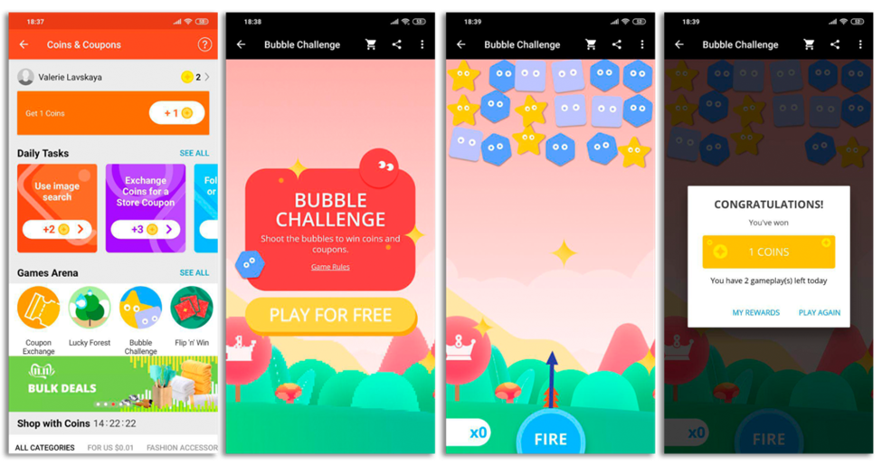*Figure 5: How AliExpress encourages users through Gamification*

Source: Promondo Team(2019)

The technique will be incorporated into the artefact in a similar fashion. Users will be rewarded for simple actions such as visiting the site, adding something to the cart, or engaging with a recommended product. Streak benefits may be applied to users who return to the app multiple days in a row. Users will then be assigned points accordingly which can then be used for features in terms of upgrading their profile or as reward points to be used towards discounts.

### **Encryption**

Although e-commerce may be the future, it must be perceived as secure for people to feel comfortable making purchases. Online shoppers need to trust that their personal data is secure in light of the rise in cybercrime. The process of transforming regular text (data) into "Cipher text" is known as encryption. Once finished, this prevents anyone from reading or interpreting the original data until it has been encrypted and returned to its original state. This makes it possible for data to be exchanged between businesses and even between individuals without running the danger of being intercepted by a third party and used maliciously or illegally.

As described by Jeeva et al. (2012), there are six main types of encryption techniques that are usually employed: AES, RSA, RC2, DES, 3DES, DSA - all of which may fall into one of two categories: Asymmetric and symmetric encryption. Below is Table 1, displaying and comparing the various types:

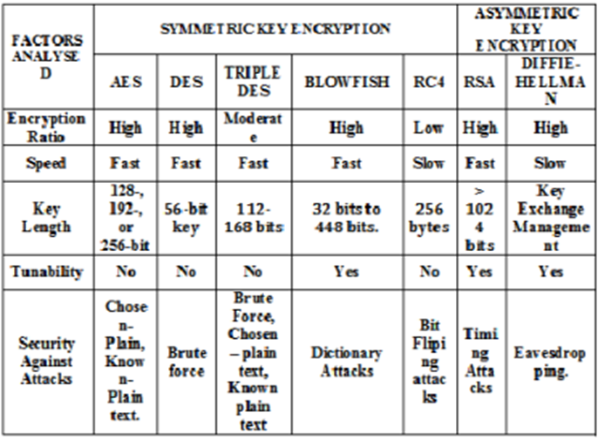*Table 1 Comparing the types of encryption and their characteristics*

*Source: International Journal of Engineering Research and Applications (IJERA) (2012)*

### 

For example, Beer (2020) states that AES-256 is the technology used to encrypt data in AWS, including Amazon Simple Storage Service (S3) server-side encryption. According to him, it would take at least a trillion years to break using current computing technology. Current research suggests that even the future availability of quantum-based computing won’t sufficiently reduce the time it would take to break AES encryption. This can be a great boon to customers’ comfort and confidence in a product, especially when it comes to sensitive information such as credit card data.

Similarly, architecture of a system is designed by using advanced encryption system –AES encryption/decryption algorithm. The symmetric key cryptosystem can protect transaction data such as account numbers, amount and other payment information from alterations. The system uses the most common method of authentication which is username and password(Olufemi et al., 2014).

This is in support of Gupta’s (2016) statements that the most widely used and easily implemented form of encryption entails having a user register a password to their username as well as recovery methods displayed in the Figure 5 & 6 flowcharts below:

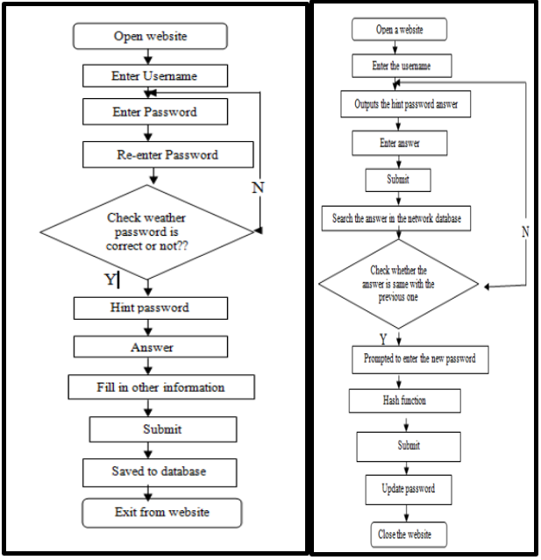*Figures 5 & 6 showing action flowchart of User Registration and Password recovery respectively* Source: International Journal of New Technology and Research (IJNTR) (2016)

Personal data of users who register on the website is saved. Their credit card information is being kept on file as they make purchases. The protection of people's personal data is crucial given the rise in hacking. The artefact will offer password and credit card encryption, lowering the risk of user exposure and enhancing the legitimacy and security of the website.

### 

### 

### **Responsive Design**

Developing websites for multiple devices has been a difficult task for the past ten years. Device features - such as screen size, resolution, internet access, operating system, etc. - change frequently and new devices emerge every day. Since W3C introduced media queries in CSS3, it's possible to develop tailored interfaces for multiple devices using a single HTML document. The approach of Responsive Web Design has been used as support for developing adaptive and flexible layouts (Johansen et al., 2013)

Responsive Design is important due to the wide variety of devices with which the artefact, being a web-based application, may be interacted with. Aside from desktop/laptop computers and mobile phones, the amount of unique peripherals gaining Internet Of Things Access is growing every day. Some may even deem it feasible to interact with the artefact using a smart TV or fridge, or a web-enabled touchscreen in a modernised vehicle. As such it is crucial that granular attention is paid to how exactly the artefact presents itself to a user on a multiplicity of screens.

As described by Voutilainen et al. (2015) creating applications that are well-suited for all of them is the next software engineering challenge for web and mobile software. Applications must be designed such that the user's applications and data shall be synchronised transparently between all the computing devices that the user has, as long as the application and data make sense for each device.Moreover, whenever applicable, roaming between multiple devices shall include the synchronisation of the full state of each application, so that the users can seamlessly continue their previous activities on any device.In addition to delivering a technical solution in the form of a framework, we also need tools and techniques for creating adaptations between different devices with different form factors, user interfaces, and modalities. Creating applications that are able to adapt to such different devices then calls for considerations regarding the different alternatives during the design. To build useful mobileUIs, UI elements must be large enough on the mobile screen.This can be achieved with responsive helpers, where elements in a full size browser can be placed side-by-side, but with smaller screens are placed top of each other. An example of such design is provided in Figure 7.

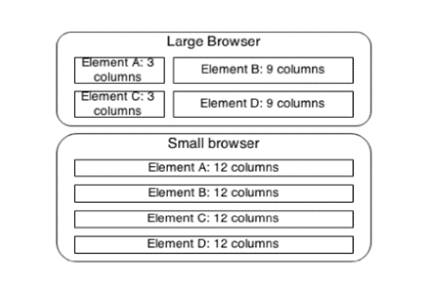

*Figure 7: Example of two browser sizes, where layout is reoriented with responsive helpers.*

Source: 2015 2nd ACM International Conference on Mobile Software Engineering and Systems

This implies the quandary of Page Layout wherein elements of a page if they are oriented in a certain way, may not display well if the screen is in the opposite orientation.

Therefore, an adapting grid system must be devised, such as the one used by domain-hosts such as SquareSpace that make the transition of a website from desktop to mobile. Figure 8 below shows how various blocks may be organised for optimum viewing using an adapting grid feature:*Figure 8: Content blocks displayed in various screen sizes and orientations.*

*Source: Insider Media (2014)*

In essence, responsive Web design is an approach to provide each Web-page in such a way that the browser can render it tailored for the available screen size.If it changes, the Web-page is adapted at runtime directly by the browser. Typical building blocks of responsive Web-pages are CSS3 media queries, relative size definitions, fluid positioning and an adapting grid-system. (Rathfux, T. et al., 2018)

As such, special consideration will be paid toward how the project artefact is to be viewed on multiple devices, with each one optimised for the cleanliness and usability of the site so as to propagate the professional feel of the site and not to dissuade potential customers who may visit the site by unorthodox means.

## 3.5 Project Related Choices

**Version Control**

Software that aids in tracking and managing changes to a software artefact's source code is known as a version control system (VCS). It preserves a record of development, allowing for a review or even a rollback to an earlier code version. As new features and issues are added to your program, using a version control solution will help you keep organised and create backups. The VCSs Git, Mercurial, TFS, and SVN are frequently used. Many IDEs and code editors, including Visual Studio, support Git.

A version control system or code hosting service will be needed for the undergraduate project in order to push code updates or get the most recent version.

GitHub and BitBucket are two well-known version control systems (both utilising the Git distributed version management technology). One can host and manage the code for the software artefact in a project using the code hosting repository GitHub. One can access and work with their GitHub repositories straight from Visual Studio by using the GitHub Extension for Visual Studio. To allow a uniform commit experience, the plugin builds on Team Explorer's Git functionality. One can publish a local Visual Studio code project to GitHub after creating it.

BitBucket, a repository service that uses either the Mercurial or Git revision control systems, is another viable option for a version control system.

The pull-based development model, enabled by git and popularised by collaborative coding platforms like BitBucket, Gitorius, and GitHub, is widely used in distributed software teams. While this model lowers the barrier to entry for potential contributors (since anyone can submit pull requests to any repository), it also increases the burden on integrators (i.e., members of a project's core team, responsible for evaluating the proposed changes and integrating them into the main development line), who struggle to keep up with the volume of incoming pull requests. (Yu et al., 2015)

According to Haaranen and Lehtinen (2015) the ability to use version control systems is a highly desired skill in the software industry and the need to teach it has been recognized in the literature. Git, and other version control systems, have previously been used by instructors in classrooms to distribute exercises, to facilitate assessment, and as a platform for project collaboration and teamwork. Using version control brings benefits to instructors, e.g. by lowering the need for administrative tasks, as well as to students, e.g. by providing experience with standard software industry tools.

The incremental nature of version control, as well as the ability to default to past versions of a code is extremely important, because of the flexibility it allows the developer in terms of producing an acceptable product in a timely manner, all the while avoiding bugs and unintended defects. It also helps in the case of recovery and correction, where the exact code that causes an error can be pinpointed along with the exact time it was included.

Nowadays, many software systems are required to be updated and delivered in a short period of time. It is important for developers to make software embrace uncertainty, because user requirements or design decisions are not always completely determined. (Ubayashi, N. et al., 2019) Hence for these reasons, GitHub will be used in the project as the Version Control System.

### **Software Development Tools**

The software development process's tool selection can genuinely be the determinant factor in a project. The next step in beginning work on a software development project is to select the tools that will be used throughout the process. This is done once the target environment and programming language(s) have been chosen, and the requirements and end goals have been sufficiently understood. It's critical to understand the several tools that can be used, the advantages that each offers, and the consequences of doing so. Numerous tools are available to support the software development process. Integrated Development Environments (IDEs) are indispensable companions to programming languages. They are increasingly turning towards Web-based infrastructure. (Coulon et al., 2020) The IDE is a collection of essential development tools that includes editors, compilers, refactorers, profilers, debuggers, project and release managers, among others. Every part of a project is visible to the developer at a glance, and modifications made in one area can be seen in all other related areas, enabling the developer to make any necessary adjustments. Many IDEs can even abstract away the build process entirely, automatically inferring the relationships between source files and libraries and rebuilding them when necessary (Faithfull et al., 2017).

Since the software must be able to generate a reliable database-oriented web application, several variables should be taken into account while choosing the software tools needed for the construction of the eCommerce Application. The cost of the software tool, how simple it is to use, my experience with it, and my ability to build on my prior knowledge and quickly acquire and master the tool will all be factors in determining the success of the application, in addition to the tool's fit to the specific requirements. The following three types of software tools were determined to be crucial:

● A Relational Database Management System for the backend to facilitate logged queries and store and retrieve information about the lodging system;

● A Web Authoring Tool for creating links between the database and the user interface on the web and for designing the user interface at the system's front end.

● A Server Scripting Language that enables the e-commerce application's functionality

As it relates to RDMS, Rhys et al. (2005) propose that XML has evolved from a document markup language to a widely-used format for exchange of structured and semistructured data, managing large amounts of XML data has become increasingly important. A number of companies, including both established database vendors and startups, have recently announced new XML database systems or new XML functionality integrated into existing database systems.

Pertaining to adequate server scripting, the dynamic scripting language PHP has become enormously popular for implementing lightweight web applications, and is widely used as a server-side scripting language for web servers. The efficiency of scripting language runtimes still matters for the end-to-end performance. However, once carefully architected and tuned, the language runtime is less of a bottleneck than the web server performance itself. (Trent et al., 2008)

Hence, of the three tools described - the artefact will be developed using XML variants such as XAMPP, an involved use of HTML and CSS for web-authoring and PHP for server scripting respectively.

### 

### **Software Development Approach**

Software development techniques offer a framework for organizing, carrying out, and overseeing the software development process. According to Vijayasarathy and Butler (2016) Many methodologies exist, including waterfall, prototyping, iterative, rapid, structured, object oriented, and agile methodologies. Each has its strengths, as well as admirers and detractors.

Determining the precise methodology for a project is crucial for practitioners. In recent years we have seen a number of different approaches to bringing software development forward by applying both new technologies and new engineering and lifecycle management practices. In particular, we have seen the emergence of agile methods as a major new paradigm for the management of software development projects. (Parsons, 2015)

Klopper (2007) indicated that making a decision, from an organisational perspective on what software development methodology to use, is no small task. Numerous users, service providers, and stakeholders are affected by it, and therefore need to take part in the process to decide on the appropriate software methodology. These groups all represent different views and needs, resulting in a decision making process that is quite often underpinned and affected by strong emotions. Organisations also use multiple methodologies on projects. Furthermore, their choice of methodologies is associated with certain organisational, project, and team characteristics.

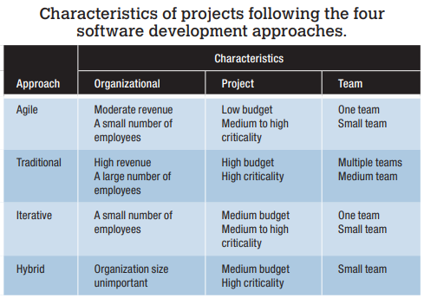

*Table 2: Comparative characteristics of different software methodologies*

Source: IEEE Computer Society

As indicated in the Table 2 above, for one-person teams working on low budget projects with a small number of staff, the agile methodology was strongly advised. Additionally, it works well when the criteria are vague or subject to change. These fit with the eCommerce project that is being created.

## 3.6 Summary

In order to ensure the success of the development and implementation of the ecommerce web application, various case studies of good examples of features were examined from pre-existing successful applications. Some of these include:

* Recommender Systems - By recommending products to customers, it is possible to raise the level of personalisation, which enhances the customer experience and boosts sales. By targeting specific customers based on past activities and recommending specific products based on them, the probability with which they may fulfil a purchase goes up dramatically.
* Ecommerce Analytics - The use of analytics in business and especially retail was always important before the advent of online purchasing. Now, given the data-collecting capabilities of today’s technology, making informed decisions on marketing and business management has been made easier than ever - decisions which ideally lead to a holistic boost in success for the business.
* Gamification - By using game-like features in the artefact, one can appeal to consumers' competitive drive and give them a reason to take action, which will raise customer engagement, loyalty, and sales.
* Encryption - It helps protect private information, sensitive data, and can enhance the security of communication between client apps and servers. In essence, when your data is encrypted, even if an unauthorised person or entity gains access to it, they will not be able to read it.
* Responsive Design - allows the website content to flow freely across all screen resolutions and sizes, and renders it to look great on all devices. It also makes it unnecessary to maintain different versions of your website for mobile and desktop and saves you time, resources and efforts.

## 3.7 Recommendations

* Recommender Systems - The application would use collaborative filtering on an item-by-item basis, which would be based on user ratings. Also returning customers will be recommended items similar to the ones they have already purchased
* Ecommerce Analytics - By using a structured database, information curated from users can be used and examined to improve the artefact and the function of the storefront.
* Gamification - The artefact will have a points-based structure where customers can accrue points for use on future purchases each time they make a purchase. This has been patently shown by various ecommerce platforms to drive user engagement by substantial margins
* Encryption - This program will offer password and credit card encryption, lowering the risk of user exposure and enhancing the legitimacy and security of the website.
* Responsive Design - Given that it is an industry standard presently to have smooth, free-flowing User Interface that can be accessed from various devices, CSS implementation will be used extensively to ensure that the application is usable and well designed regardless of the screen it is accessed from.

### 

# 

# CHAPTER 4: REQUIREMENTS ANALYSIS

## 4.1 Introduction

According to Chakraborty et al. (2012), the requirements analysis phase of the systems development life cycle (SDLC) is the most crucial because it is used to create a set of precise and unambiguous requirements that will be applied in later stages of the project and serve as the foundation for the creation of the system. The methods used to gather the requirements are described in this chapter, along with a summary of the system's functional and non-functional requirements. A number of documents, such as use case diagrams and activity diagrams, are also provided.

## 4.2 The Process of Producing the Requirements

Gathering the needs for the online auto-part store involved a number of methods. This involved visiting various related websites, including Amazon.com, eBay.com, alibaba.com etc. The basic and advanced objectives were built on a comparison of the websites and the elements they used. The majority of ecommerce websites include needs like registration, cart management, product filtering and customer ratings.

The background investigation also had a significant impact on the requirements. Based on the background study done, features including responsive design, recommender systems, and the utilisation of gamification were included.

## 4.3 Personas

One of the tools used in system development is the user persona. This is a fictional profile of potential customers and is used to identify user needs. During the life cycle of the project, these profiles are used to virtualize interaction with the system based on these fictional profiles. Figures 9 & 10 below depict examples of such.

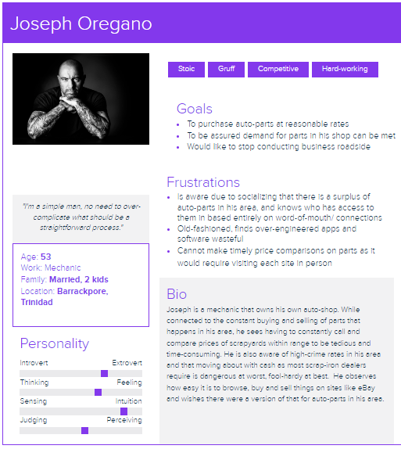

*Figure 9: Persona 1*

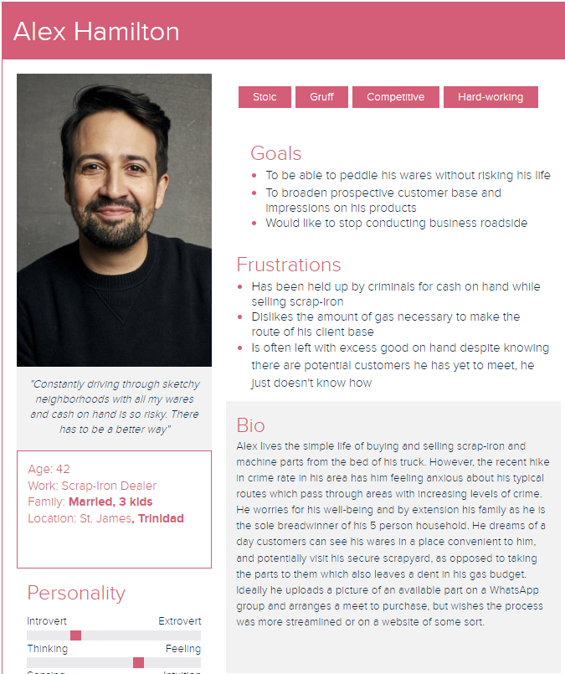

*Figure 10: Persona 2*

## 

## 4.4 The Requirements

The list of requirements for this project was influenced by the work done in the background research chapter as well as reviewing other ecommerce websites such as Amazon and ebay. Requirements comprise two different types, Core and Advanced. Core Functional Requirements are basic requirements that are ideally considered mandatory in the system and easier to develop. Advanced Functional Requirements are considered as “nice to have” and are considered more complex to develop but will yield a more sophisticated solution. The following is a list of features that the project will deliver. They comprise of both core and advanced features. Table 3 Below depicts such requirements and their access:

| Requirement ID | Requirement | Requirement Type | Access |
| --- | --- | --- | --- |
| FR1 | Registration | Core | Public |
| FR2 | Cart Management | Core | Public |
| FR3 | Product Inventory Management | Core | Admin |
| FR4 | Product Filtering Tool | Core | Public |
| FR5 | Customer Ratings | Core | Registered User |
| FR6 | Customer Profile Management | Core | Admin |
| FR7 | Best Sellers Page | Core | Public |
| FR8 | Online Payment | Advanced | Registered User |
| FR9 | Referral Programme | Advanced | Registered User |
| FR10 | Gamification | Advanced | Registered User |
| FR11 | Analytics | Advanced | Admin |
| FR12 | Responsive Design | Advanced | Public |
| FR13 | Artificial Intelligence Chatbot | Advanced | Public |
| FR14 | Recommender System | Advanced | Public |

*Table 3: Shows a list of Functional Requirements for the Application*

For each requirement, a detailed description and rationale was created in the Appendix C. This description outlines the function's operation, the data needed to complete the function, and any necessary validation checks. In the phases of development for the design and implementation, this will be useful. The information needed to create the requirement FR1 Registration on an account for the artifact is shown in Table 4 below. For a complete list of non-functional needs, see table 4 below, and for a complete list of criteria, see Appendix C.

| **Requirement** | **Registration of an Account** |
| --- | --- |
| Number | FR1 |
| Description | The user must register before making a purchase on the website. This requires the user to enter their first name, last name, e-mail address and a password. The program verifies that the email address is distinct and that the password complies with the requirements (at least 8 characters including one lower case letter, one uppercase and one number). Once the information has been validated, a record will be stored in the database in the ‘users’ table.The user is subsequently informed via a notification that his registration was successful. |
| Rationale | Once a user registers an account on the application, he is able to purchase items, view order history, track order status and delivery, edit profile information such as addresses, password and credit card information. |

*Table 4: Registration Requirement Detail*

#### 

#### **4.5 Non Functional Requirements**

Non-Functional requirements are those features that are just as important to the application but the less tangible aspects of it.It focuses more on what the user expects, and some of these aspects include compatibility with different browsers, quickness, security, scalability, and accessibility, to mention a few. The non-functional requirements for the application are listed in Table 5 below.

| **Non-Functional ID** | **Requirement** | **Rationale** |
| --- | --- | --- |
| NFR-1 | Browser Compatibility | Many different mobile and desktop browsers, including Chrome, Safari, Firefox, and Microsoft Edge, should be able to access the application. |
| NFR-2 | Application  Security/Encryption | Sensitive data such as credit card information should be encrypted in the database to protect privacy of information from other users and hackers. To guarantee that users only have access to their information and not that of other users, access controls must be put in place. |
| NFR-3 | Database Security | Only database administrators and not users should have access to the database. The application interface should be the only way users can access the database. |
| NFR-4 | Availability/Reliability | The platform on which the application is hosted must be dependable and trustworthy in order for the provider's SLA to be compliant with industry standards. This will guarantee that the application is constantly accessible with little downtime. |
| NFR-5 | Scalability and Performance | The system ought to be easily scalable to accommodate future growth and alterations, if necessary. It should be able to grow to meet expected traffic and function efficiently during peak times, such as load pages and respond to requests quickly for the user. |
| NFR-6 | Maintainability | The application's design should make it simple for users to add, edit, and update products and user information.. |
| NFR-7 | Usability | The application's user interface should adhere to Nielsen's criteria for system status visibility, consistency, and standards. Some elements will be similar to other e-commerce sites such as navigation links, layouts and pages. |
| NFR-8 | Consistency | This emphasizes how the user interface looks and functions, making sure that the look and feel are constant across the application. These may contain components like button kinds, color schemes, and fonts that must all be used consistently throughout each page.. |

*Table 5: Non-Functional Requirements*

## 

## 4.6 Use Cases

A Use Case diagram is used to graphically display the expected behaviours of a system and the methods of executing various processes.

One of the use cases is purchasing a product through the application. This involves the following steps.

1. A registered user logs into the site.
2. The user browses the product catalogue.
3. The user selects an item.
4. The user adds the item to their cart.
5. The user clicks checkout.
6. The user pays using saved or new financial information.
7. The order is placed and finalized.

This is depicted in the Figure 11 below:

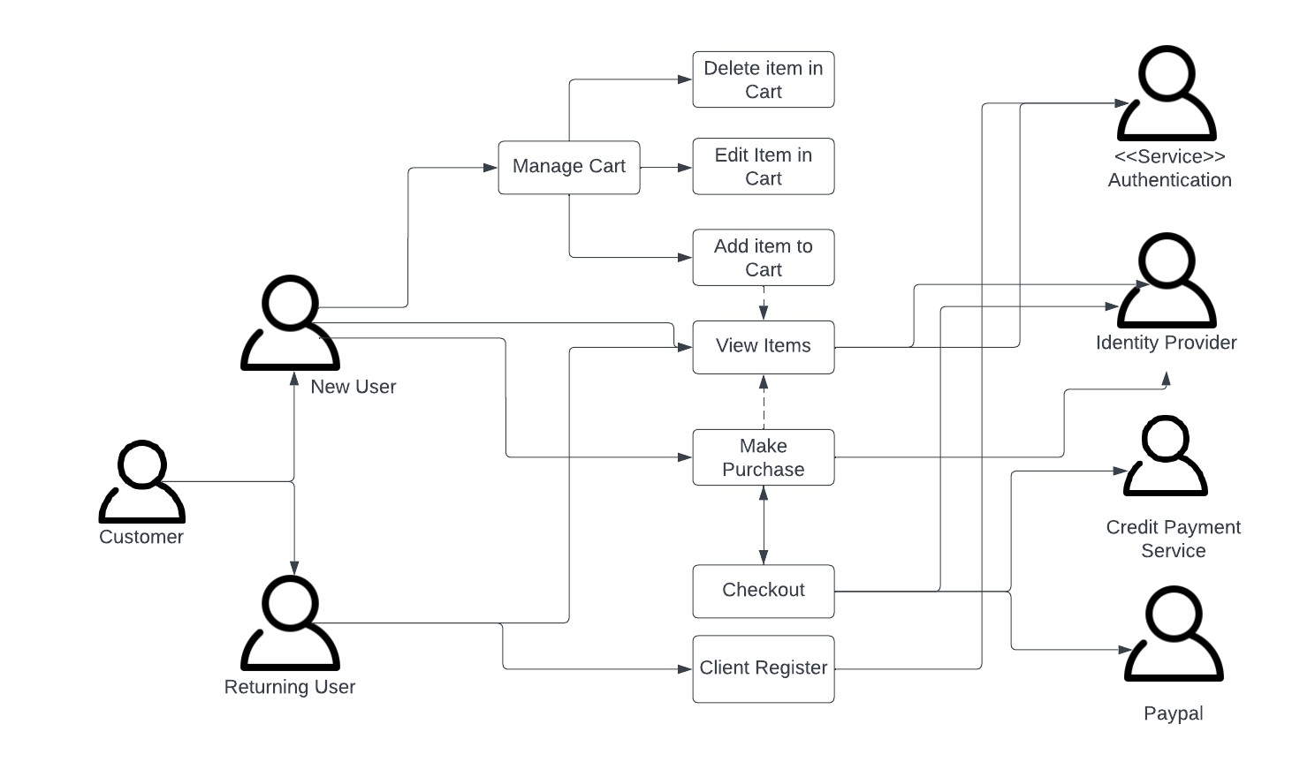

*Figure 11: Use Case Diagram*

## 4.7 Information Architecture

The main challenge was classifying the content into groups that would indicate a logical and structured method to obtain information on the website after conducting the research, analysing the data, and synthesising it. The thorough descriptions that were supplied for each requirement had an impact on the flow. A sitemap was designed to facilitate the organisation of the contents and illustrate the connections between the various pieces of content on the website. From the homepage, groups of content categories with labelled stacks of pages can be found. These pages serve as the individual product pages from which a user can access the checkout page for their shopping cart.

A sitemap was created to help with content management and highlight the connections between the various pieces of content on the website. From the homepage, collections of content categories that are stacked with labelled pages branch off. These are the several product pages from which a customer can proceed to the shopping basket page and check out.

The Figure 12 below shows the information architecture (Site Map) for the project.

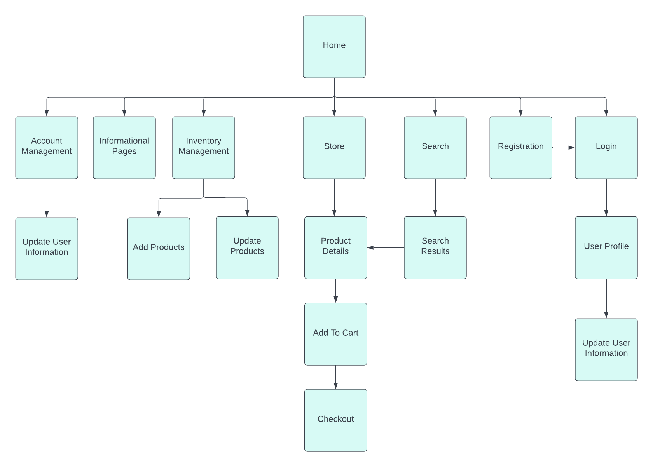

*Figure 12: Application Site Map*

## 4.8 Activity Diagrams

Activity Diagrams are used to describe how processes are executed to provide some type of resource or service based on an input or operation. The activity diagram for the process for purchasing an item is seen in Figure 13 below.

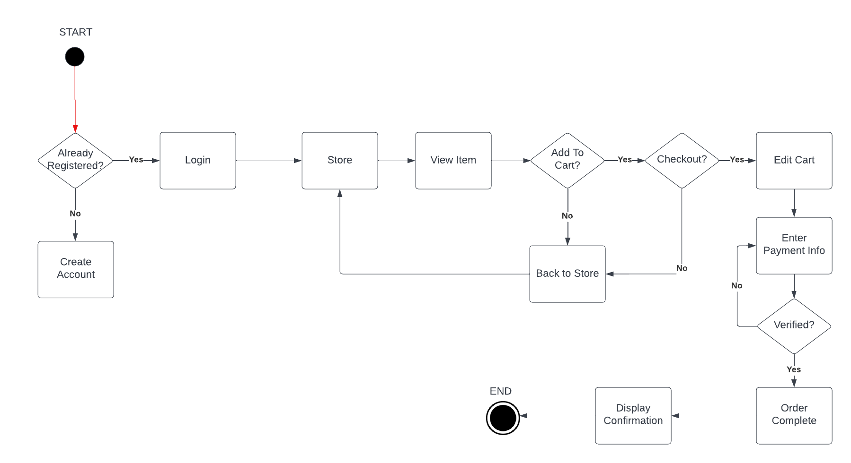

*Figure 13: Activity Diagram for the System*

# CHAPTER 5: DESIGN

## 5.1 Introduction

While a professionally created website will entice visitors and instil trust in their consumer base, a poorly designed website can have numerous detrimental effects on a company. To compete successfully in today's competitive climate, you must prevent the harm that can be done to your firm by poor website design. The design choices taken into account when creating the software artefact are discussed in this chapter. Both the design of the user interface and the database that must be used to hold the data are examined. It also takes into account HCI concerns and how they affected the design.

To design the ecommerce system, various tools and models will be used to design both the backend and frontend of the application. Before creating the logical schema for the backend, the logical and conceptual model will be developed using an Entity Relationship Diagram (ERD). Wireframes will be used during the frontend design process.

## 5.2 Database Design (Back End Design)

### 5.2.1 ERD

**ENTITY RELATIONSHIP DIAGRAM**

The entities and the data these entities would store were identified using the requirements analysis and the Entity Relationship Diagram (ERD). The users table, which would include user data such as first and last names, email addresses, and passwords, is an illustration of one of these entities. The ERD diagram below displays the remaining entities. After listing these entities and the information that would be stored in each, the relationships between the entities were established; in cases where there was a many-to-many link between the entities, a new entity was created to break this many-to-many relationship. One example of this is the addition of an entity for order information. By eliminating the many-to-many relationships that exist between entities, a procedure known as normalisation is used to reduce redundancy and ensure that the data in data dependencies make logical sense. The normalised Entity Relationship Diagram can be seen in the Figure 14 below

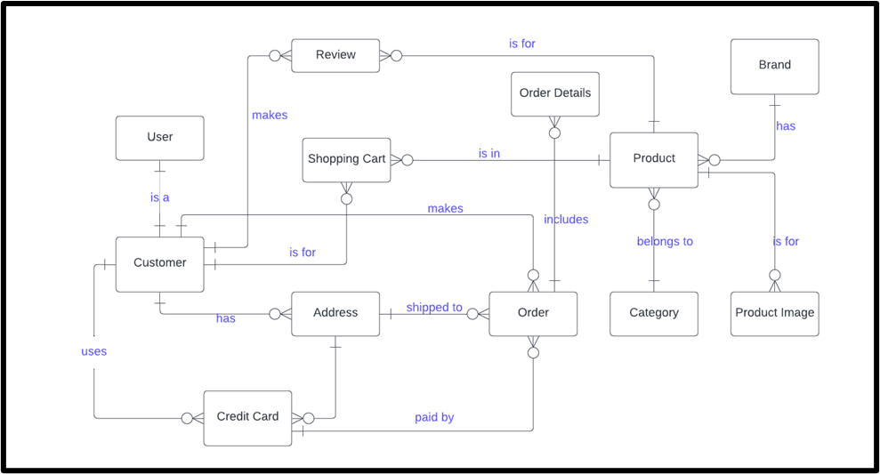

*Figure 14: Normalised Entity Relationship Diagram*

*Source: Tristyn Horrell (2022) using lucid.app/lucidchart*

### 5.2.2 Normalisation Process

The following stage was to determine the relationship between these entities and the

cardinality of these relationships. A product can have one shopping cart, but the shopping

cart can have multiple products. This process is known as normalisation, which leads to

constructing a hypothetical ER Diagram.

### 5.2.3 Logical Model

**LOGICAL SCHEMA**

All of the logical restrictions that must be applied to the stored data are specified in the logical schema. Tables, views, and integrity restrictions are defined. It originates with the logical ERD. The ERD entities created the table in the logical schema. Since there were twelve (12) entities in the ERD created in accordance with the logical schema, there were twelve (12) tables.The tables' attributes were created from the characteristics of the entities.

The ecommerce system's logical structure is displayed in Table 6 below.

| **ENTITY** | **ATTRIBUTES** |
| --- | --- |
| User | UserID, email, password, RegisteredDate, userType |
| Customer | CustomerID, UserID*, firstName, lastName, phone |
| Address | AddressID, CustomerID*, addressLine1, addressLine2, city |
| Credit Card | CreditCardID, AddressID* creditCardNumber, expiryDate, securityCode |
| Order | OrderID, CustomerID*, AddressID*, CreditCardID*, orderDate, orderTotal, paymentDate |
| Order Details | OrderDetailsID, OrderID*, ProductID*, quantity, unitcost |
| Shopping Cart | ShoppingCartID, ProductID*, CustomerID*, quantity, price |
| Review | ReviewID, ProductID*, CustomerID*, reviewText, reviewDate, rating |
| Product | ProductID, BrandID*, CategoryID*, productName, description, price |
| Product Image | ProductImageID, ProductID*, image |
| Category | CategoryID, categoryName, description, image |
| Brand | BrandID, brandName, image |

*Table 6: Logical Schema of the ecommerce system with corresponding attributes*

### 5.2.4 Data Dictionary

The data dictionary is an elaboration of the data selected in the logical schema. This information describes each field in an entity and defines it based on Data Type, Length, Constraints and Description of the field.

Below is an example of the data dictionary for the user table depicted in Table 7

| **Table: users** | | | | |
| --- | --- | --- | --- | --- |
| Field Name | Data Type | Field Length | Constraint | Description |
| userId | Integer | 11 | Primary Key | The user ID of the user, autogenerated |
| firstName | Varchar | 100 | Not null | The first name of the user |
| lastName | Varchar | 100 | Not null | The last name of the user |
| email | Varchar | 100 | Unique and must contain the ‘@’ symbol | The email address of the user |
| password | Varchar | 300 | Must contain at least one upper and lowercase letter, one symbol and one number | User password used for logging in |
| contact | Integer | 11 | Not null | Contains the value for the region ID from the region table |
| addressLine1 | Varchar | 300 | Not null | The first line of the user’s address |
| addressLine2 | Varchar | 300 | Not null | The second line of the user’s address |
| country | Varchar | 300 | Not null | The user’s country |
| stateRegion | Integer | 11 | Not null | Contains the value for the town city ID from the town city table |
| points | Integer | 11 | Not null | The points of gamification |
| regDate | Date | - | Not null | The date of creation of the account |
| userType | Varchar | 20 | Either ‘user’ or ‘admin’ | The type of user account |

*Table 7: Data Dictionary*

## 5.3 Application Design (Front End Design)

### 5.3.1 Nielsen’s Heuristics

In order to provide the optimum user experience, which includes effectiveness, speed, and fluid functionality, front-end development is done. The design principles and Nielsen's 10 Usability Heuristics (Nielsen, 1994) were used to make sure the artefact adhered to acceptable design standards.

Table 8 below provides an illustration of one of Nielsen's ten usability heuristics.

| **Heuristic #9: Help users recognize, diagnose, and recover from errors** | |
| --- | --- |
| **Description**: Error messages ought to be written in plain English (i.e., without using error codes),clearly state the problem and constructively provide a solution. | |
| Practical Application | If a user enters an erroneous password upon login, they will receive an  "Password does not match" error message is displayed.  The user will automatically be forwarded to the login page.  Upon entering a registration email that is already in the database  An error notice explaining that the user was unable to register will appear.  Use a different email address; this one is already in use. This person will  you will then be taken instantly to the registration page that also  contain a link that, if they are not already there, directs them to the login page  immediately routed. |

*Table 8: An example of Nielsen’s Heuristic use in the artefact*

### 5.3.2 Sketches

Every brainstorming session for a web design project should start with a drawing. Understanding what might happen with a design may be made easier by visualizing a project from the outset. Sketching can be used to assist clarify ideas, provide useful feedback, and keep the project moving forward while the design process progresses.

Sketches have the advantages of being portable, approachable, inventive, and time-tested. A site designer can quickly produce ideas with a pencil and paper, reducing the number of billable hours spent in front of a computer. Figure 15 shows the sketch of the Store Page and Login Page.

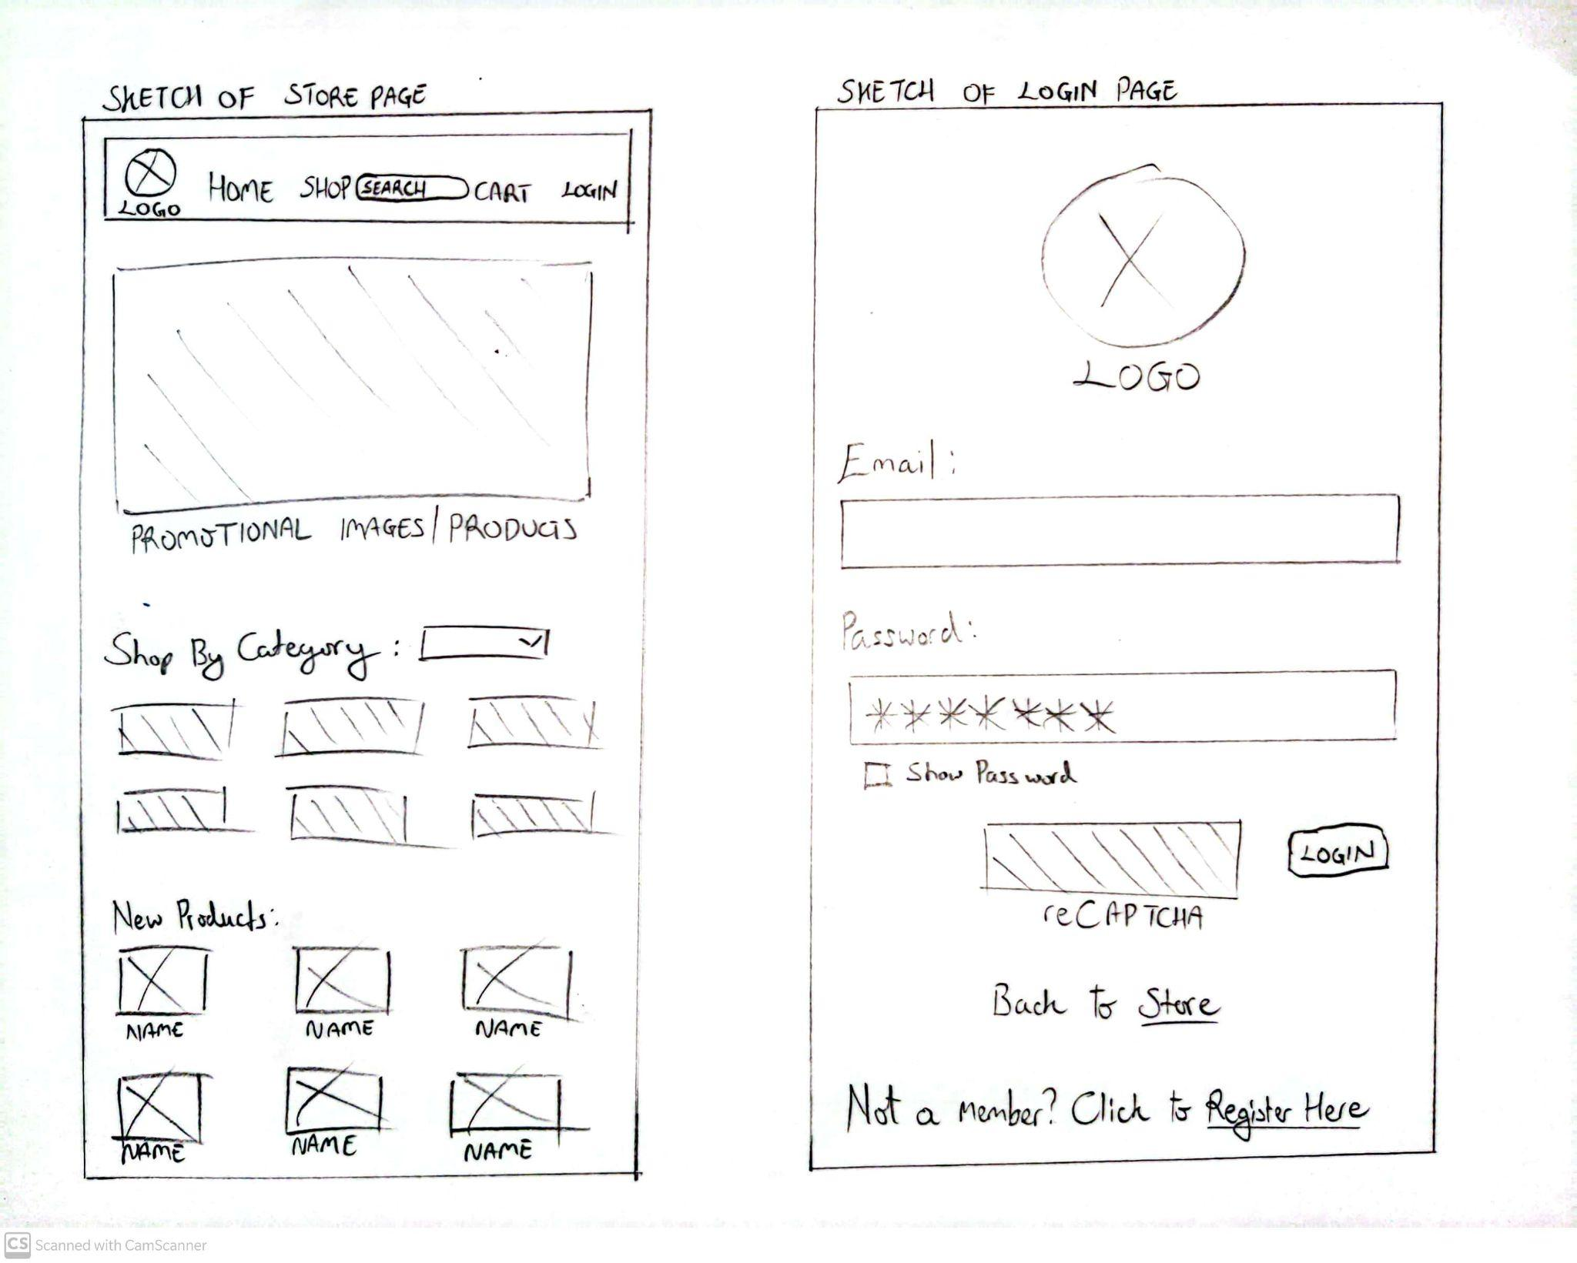

*Figure 15: Preliminary sketch of Store and Login Page*

The layout was inspired by ecommerce websites I would have visited in the past as well as other related websites that sell similar products to overseas markets such as carparts.com

### 5.3.3 Wireframes

According to Guilizzoni (2020), a wireframe is a schematic or blueprint that is helpful in facilitating communication and thought among users, programmers, and designers concerning the structure of a software or website under development. They are static visual designs that represent how the software's creator intended it to appear. The artefact's login page's wireframe is depicted in Figure 16 below. The Appendix D has additional wireframe illustrations.

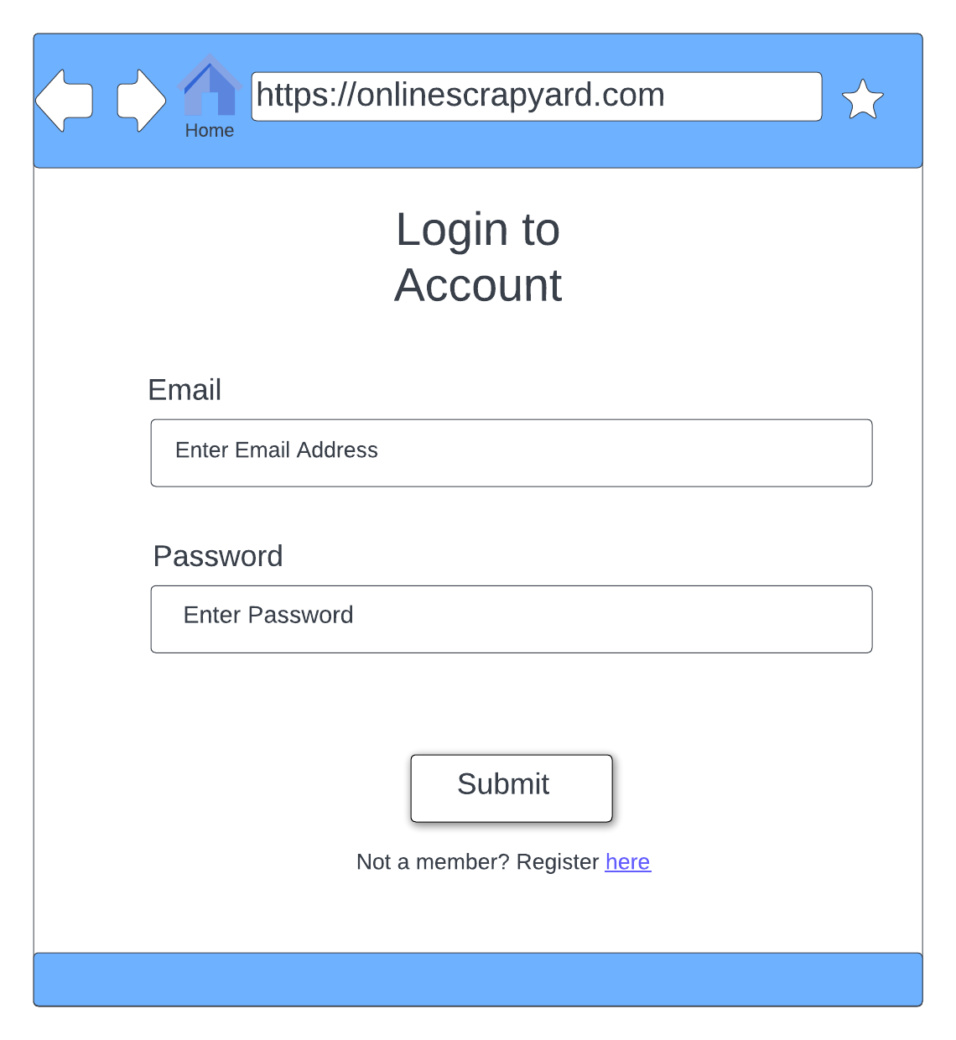

*Figure 16: Login Page Wireframe for the artefact*

*Source: Tristyn Horrell(2022) using lucid.app/lucidchart*

When it comes to design philosophy as it pertains to technology I believe minimalist layouts help simplify the user experience and evoke a sense of modernity and elegance when done correctly. While not too extravagant I believe a simple login page is the best fit for new users making the process easy to learn and remains familiar for returning users.

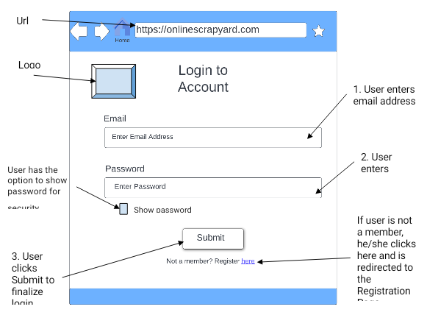

*Figure 17: Annotated Login Page Wireframe*

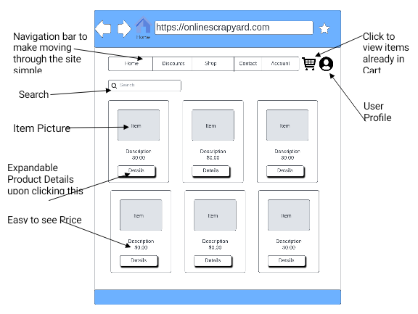

*Figure 18: Annotated Store Page Wireframe*

While there are many different categories under which auto parts may be broken down into, I believe having a splash page of all items available will encourage users to post their own listings should they see something similar to an article they would like to price or auction. It also contributes to a sense of abundance on the page and reinforces the idea that any mechanic or prospective auto part buyer can find what they need on the site.

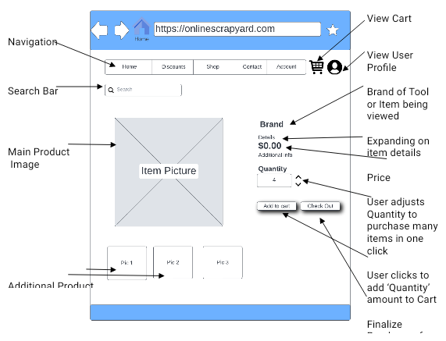

*Figure 19: Annotated Product Detail Page Wireframe*

In the wireframe shown in Figure 19 above, I tried to emulate the details page of Amazon.com wherein a user has a large picture of the item at hand and can quickly and easily adjust the quantity of it to be purchased. The user experience is further bolstered by convenient ‘Add To Cart’ and ‘Checkout’ buttons as well as having additional images to further acquaint users with an item they may be interested in.

### 

### 

### 

### 

### 

### 5.3.4 Interactive Prototype

An interactive prototype is crucial to the design as it depicts presentation and design concepts that clients and stakeholders may be invested in. It is one step above the Wireframe in that it also allows design elements such as colour psychology to be used, which is crucial in the decision making process of a potential customer in the sales funnel. The colours I deemed to use were blue and white as to depict a sense of trust, harmony and loyalty while evoking a theme of simplicity, minimalism and honesty which elevates the feeling of candour and transparency on the user’s part. As such blue will also be used on the site’s buttons and links to form a sense of unity and cohesive elements. Using this colour, a prototype of a potential logo was designed as follows in Figure 20

Subsequently the Figures 21 & 22 below respectively show what an ideal Login and Registration page would look like using the logo in both a desktop and mobile format.

### 

*Figure 20: Proposed Logo Prototype*

### 

*Figure 21: Prototype of Login Page showing Responsive Design*

### 

*Figure 22: Prototype of Registration Page showing Responsive Design*

# CHAPTER 6: IMPLEMENTATION

## 6.1 Introduction

This phase of the project is arguably the most crucial as it entails and describes the actual development and functionality of the artefact itself. It outlines the practical work involved in the project which includes installation of the necessary software, construction of the database and the application itself, as well as using all the constituent back-end and front-end elements in tandem by having them communicate effectively towards the purpose of the artefact. These tools were crucial in the development cycle and without their efficient use and implementation the development of the application would not be possible.

**The Development Environment**

The integrated development environment or IDE used was Microsoft Visual Studio Code. It was chosen due to the practicality with which a software can be developed, its user-friendly nature especially for students and first-time developers, its inclusion and ease of implementation of version control plugins, extensions that enable debugging and automatic formatting, highlight and tag matching and error amending functionalities.

It was used together with XAMPP, which allows a MySQL server to be run locally on the student’s computer for hosting purposes, negating the need to purchase servers or hosting services during development. Visual Studio Code was also essential due to its ability to integrate and seamlessly incorporate multiple languages that were used in the development cycle, those of which include:

* JQuery - A Javascript editor that simplifies HTML page navigation and event handling.
* HTML - HyperText Markup Language is the core atomic element upon which the structure and functionality of most web pages exist and is usually used in the creation of web content, such as an e-commerce online store.
* CSS - Cascading Style Sheets formats and depicts how HTML elements are displayed and is used in the web page design and user interface experience.
* PHP - Originally derived from Personal Home Page which is now recursively known as Hypertext Preprocessor, this is a server scripting language for making changing and interactive web pages.

Installation of the IDE and XAMPP was a straightforward process that required minimal configuration. XAMPP entailed the use of development of the database backend using PHPmyadmin module interfaced using the browser Google Chrome. Support in interconnecting these varying softwares and having them communicate is readily available on Youtube with a plethora of troubleshooting and tutorial videos.

## 6.2 Database Implementation

MySQL was chosen to create the database of the application. It is an open-source, relative database management system used in conjunction with the XAMPP server. The database was developed and named “class_database” and the tables were created along with primary and foreign keys. Figures 23, 24 & 25 below show the tables and columns used in the database via MySQL and the Administrative aspect of phpMyAdmin respectively.

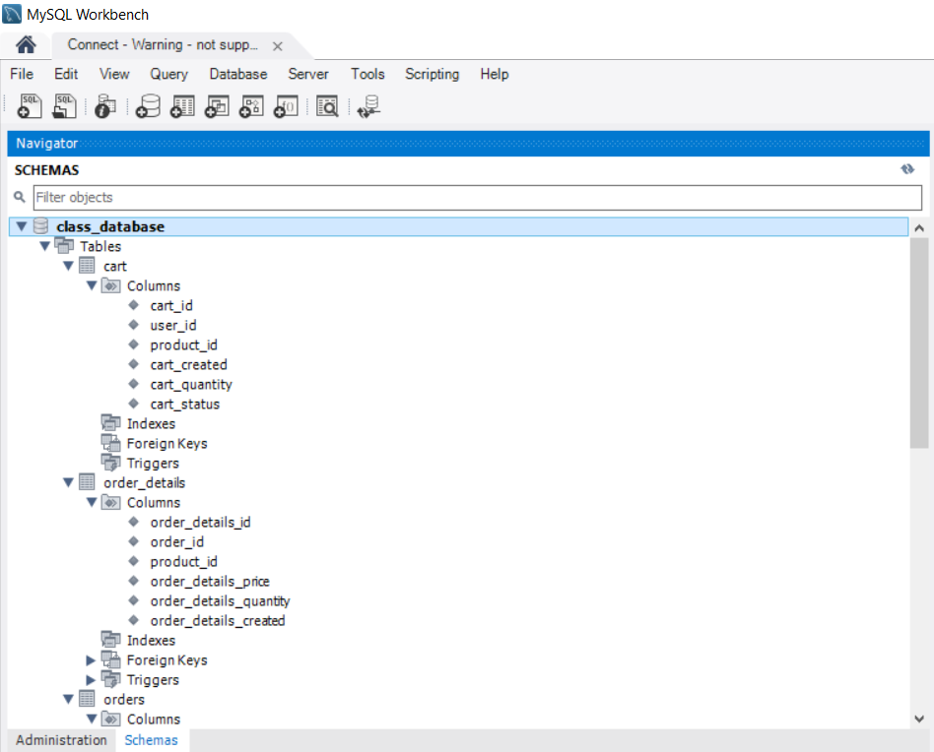

*Figure 23: Screenshot 1 of MySQL Database*

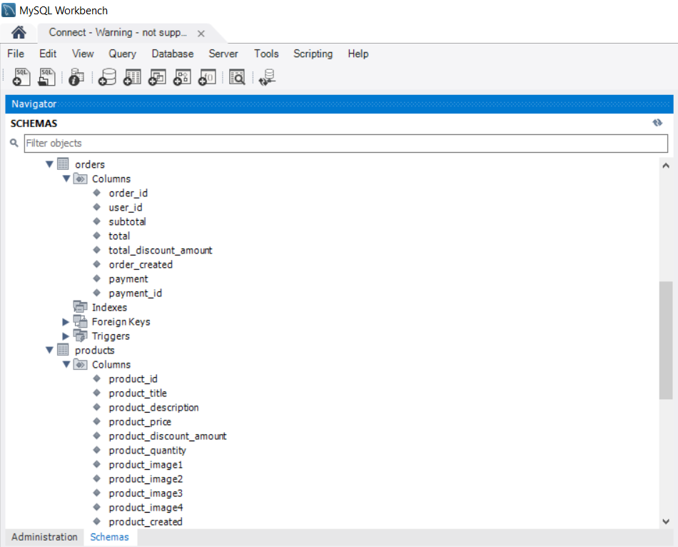

*Figure 24: Screenshot 2 of MySQL Database*

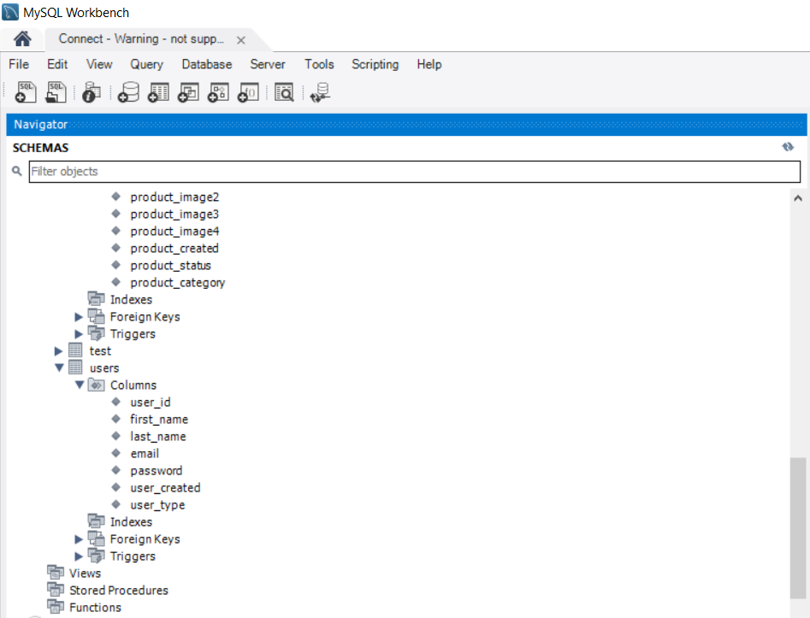

*Figure 25: Screenshot 3 of MySQL Database*

Furthermore, Figures 26, 27 & 28 below depict the browser-based phpMyAdmin Columns.

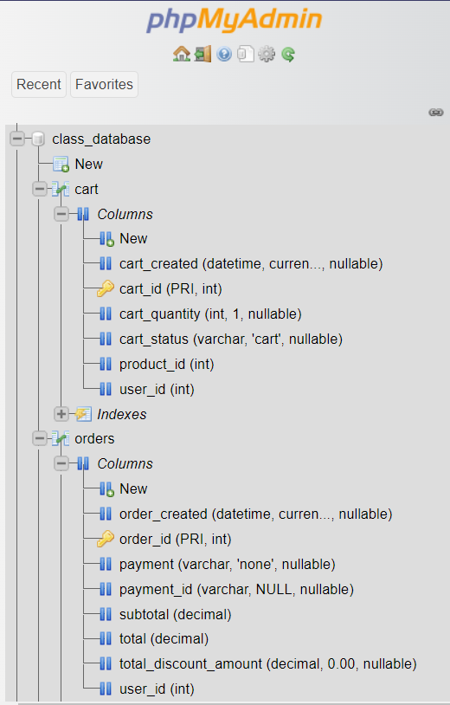

*Figure 26: Screenshot 1 of phpMyAdmin Columns and datatypes*

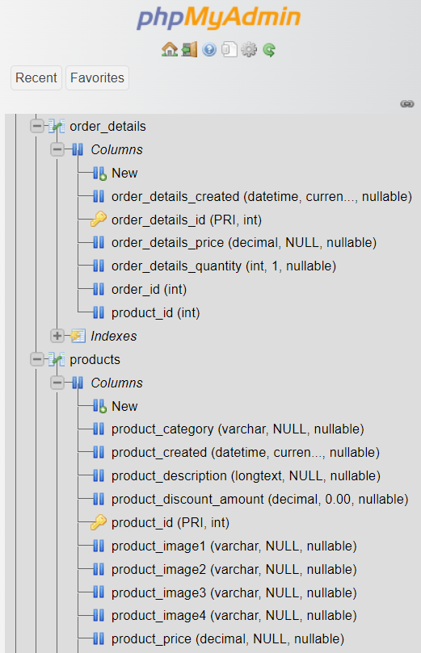

*Figure 27: Screenshot 2 of phpMyAdmin Columns and datatypes*

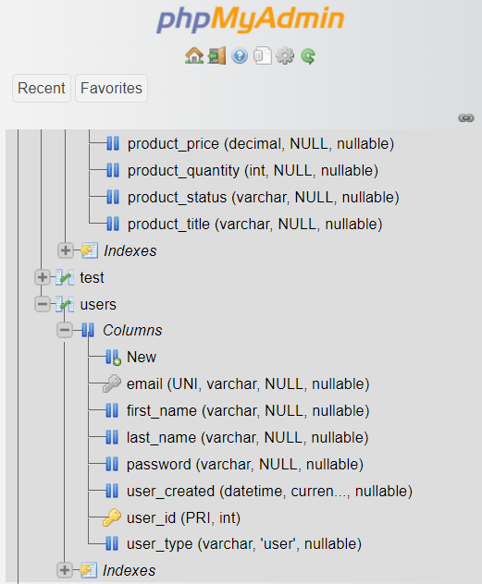

*Figure 28: Screenshot 3 of phpMyAdmin Columns and datatypes*

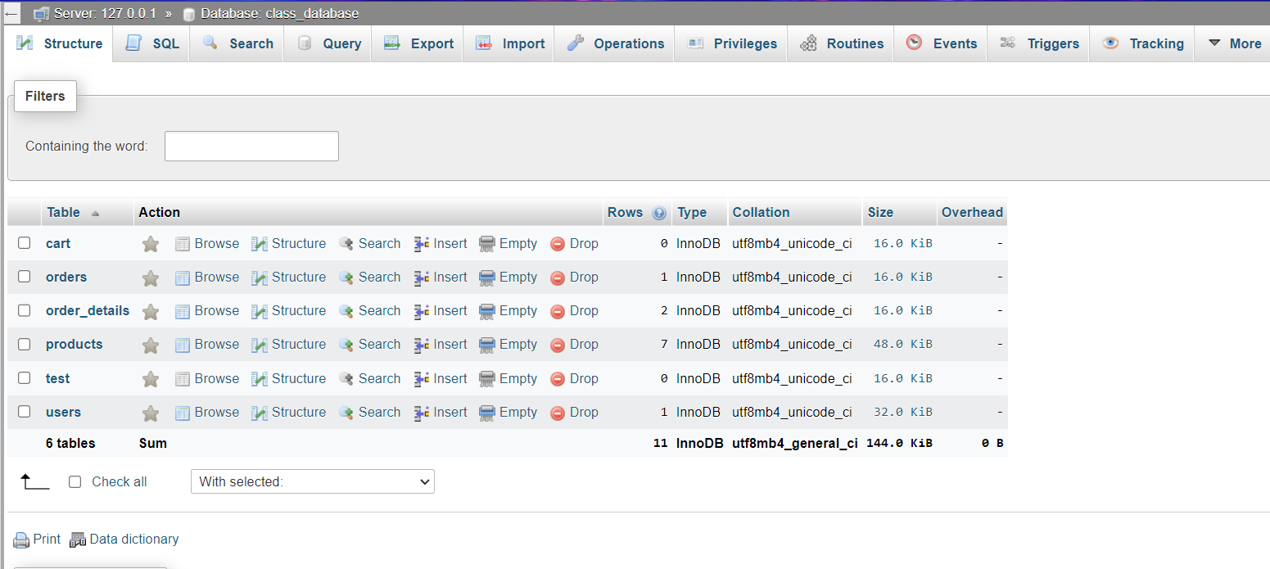

*Figure 29: Structure of phpMyAdmin database*

Each Index, column and datatype was manually constructed bearing in mind the practicality of the application and the expected user and admin inputs. The constituent tables can be seen in Figure 29 above

### 6.2.1 Database Amendments

During development, there was a problem getting MySQL to start in XAMPP and under the direction of my instructor, XAMPP had to be reinstalled and the entire database rebuilt. While it was eventually amended, it crucially cut into development time and was a large hindrance in the flow of the development of the project.

## 

## 

## 

## 

## 6.3 Connection between Database and Front End

The database included all the data necessary in the functioning of the application such as orders, users, products etc. It also facilitated login functionality by coupling a user’s email with their password which was to be encrypted before storing on the database. The customer would interact with said data using the web pages and UI (user interface) created in Visual Studio Code. The connection code is a php string designed to allow the database to seamlessly send and receive data from the application and vice-versa. This string was stored in a file named Database.php located in the Configuration section of the project folder. Figure 30 shows the connection strings in the php file.

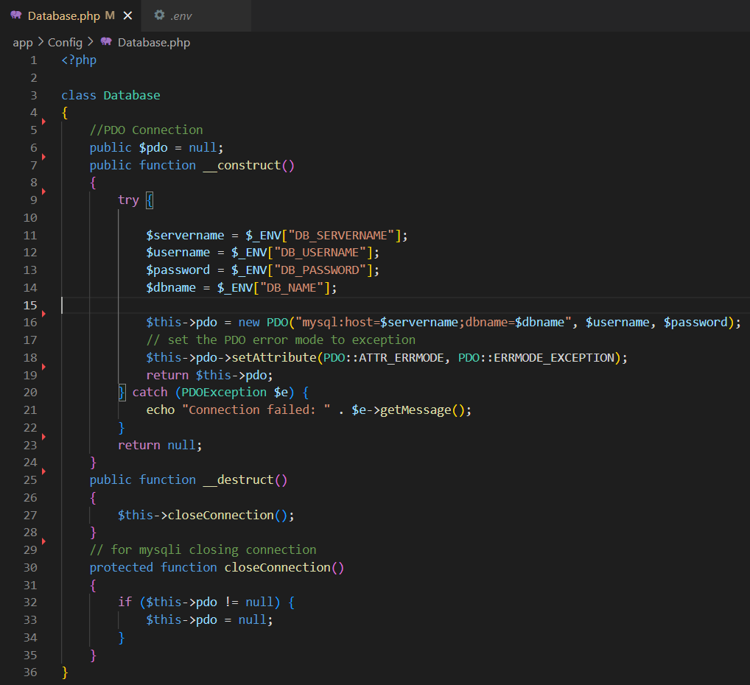

*Figure 30: Snippet of Code for Database*

## 

## 6.4 User Interface Implementation

Around 13 of the 14 requirements have been partially if not totally implemented. This section entails these features as well as includes snippets of code and discussion of the implementation of these features. Table 9 below organises them by Core and Advanced Requirements

| Requirement ID | Requirement | Requirement Type |
| --- | --- | --- |
| FR1 | Registration | Core |
| FR2 | Cart Management | Core |
| FR3 | Product Inventory Management | Core |
| FR4 | Product Filtering Tool | Core |
| FR5 | Customer Ratings | Core |
| FR6 | Customer Profile Management | Core |
| FR7 | Best Sellers Page | Core |
| FR8 | Online Payment | Advanced |
| FR9 | Referral Programme | Advanced |
| FR10 | Gamification | Advanced |
| FR11 | Analytics | Advanced |
| FR12 | Responsive Design | Advanced |
| FR13 | Artificial Intelligence Chatbot | Advanced |
| FR14 | Recommender System | Advanced |

*Table 9: Table of Functional Requirements*

### 6.4.1 Core Features Implemented

**Registration**

This feature gives users the ability to create an account on the site which is necessary to access the storefront page as well as keeping a history of their information and purchases. It accepts the user’s First Name, Last Name, a unique email address that serves as a username which is used together with a password the user sets to log in to the application after they have registered. This is done using the “password_hash” tag so that the password is encrypted before it is stored in the database for the user’s safety as shown in Figure 31 below.

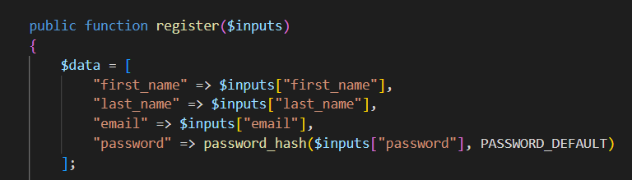

*Figure 31: Snippet of Code Used to Register*

It should be noted that the Laravel tag ‘PASSWORD_DEFAULT’ was also used so that the password is masked in the input field while entering the information as is standard practice across most registration and login pages indicated in Figure 32 below:

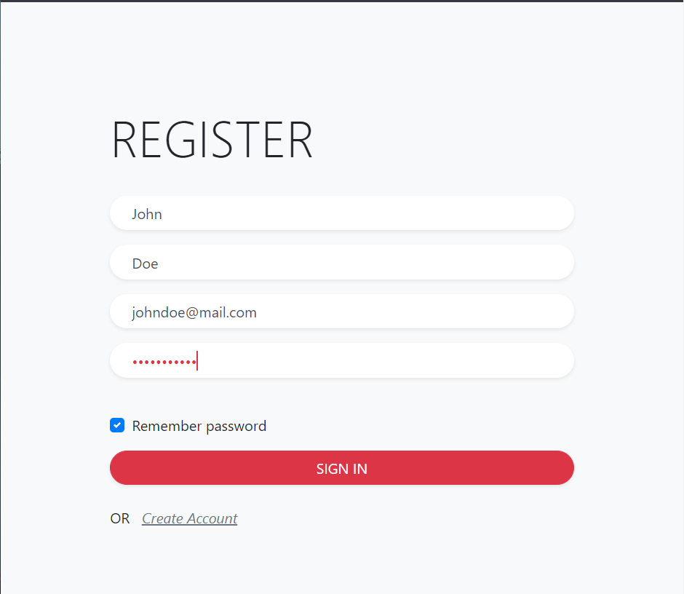

*Figure 32: Screenshot of artefact’s Registration Page with masked Password input field*

**Login**

This allows an already registered member to login to the application. This gives the user the ability to perform transactions under the username they would have used to register. As with the registration page, the password is both masked upon input and hashed to protect the user. Figures 33 & 34 below show the code implemented for login functionality as well as the actual login page of the application respectively

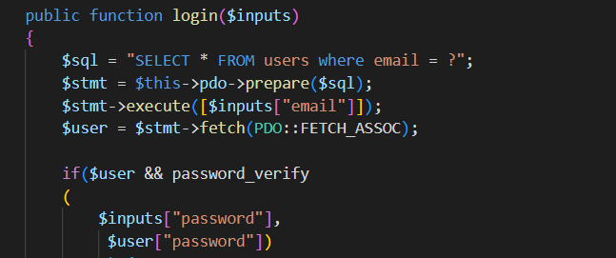

*Figure 33: Snippet of Code for Login Functionality*

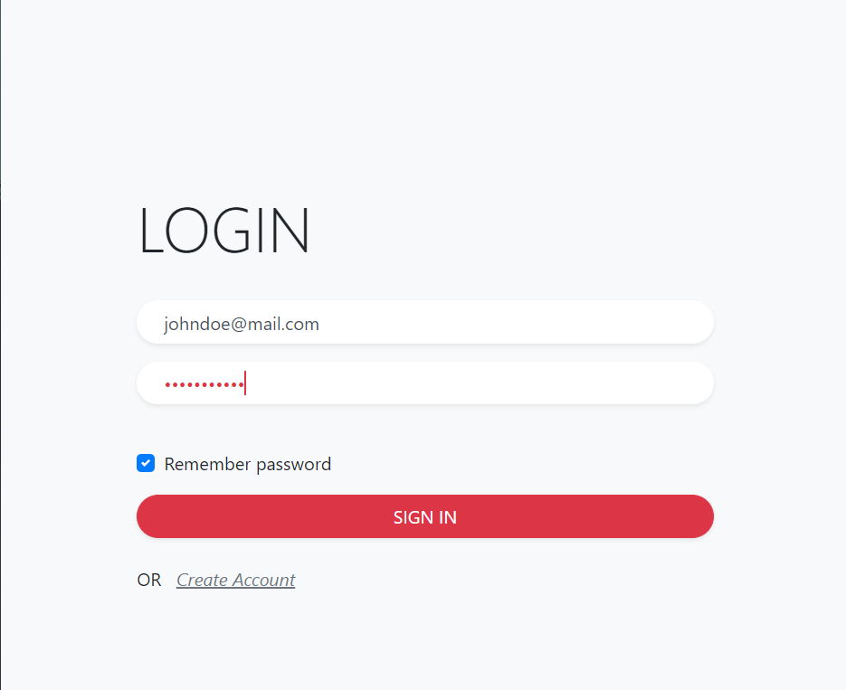

*Figure 34: Screenshot of Artefact’s Login Page with masked Password Input Field*

When the user is successfully logged in the site will inform the user by means of an alert. The alert will also show an error message upon unsuccessful login as shown in the Figure 35 below.

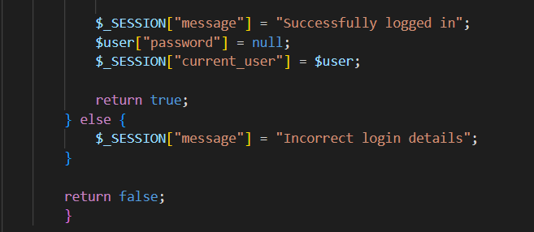

*Figure 35: Snippet of Code for Login Alert*

**Cart Management**

The ability to Add, Edit and Remove Items from the Cart is crucial in any ecommerce system. In the sense that an item is being added, its corresponding price data from the database is added to the user’s ‘Subtotal’ which sums to a ‘Total’ so that multiple items can be purchased at the same time at checkout. This is done by identification of a product id, which is coupled with any individual item in the database. This functionality can be seen in the code snippet in Figure 36 below:

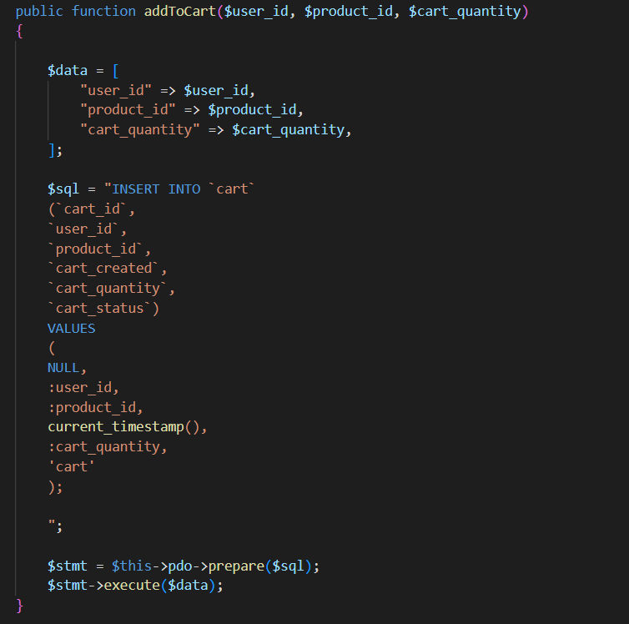

*Figure 36: Snippet of Code for Cart Functionality*

A ‘multiInsert’ function can be used to order multiple quantities of a specific item should the user want to alter the amount of said item to be ordered, which is depicted in Figure 37 below.

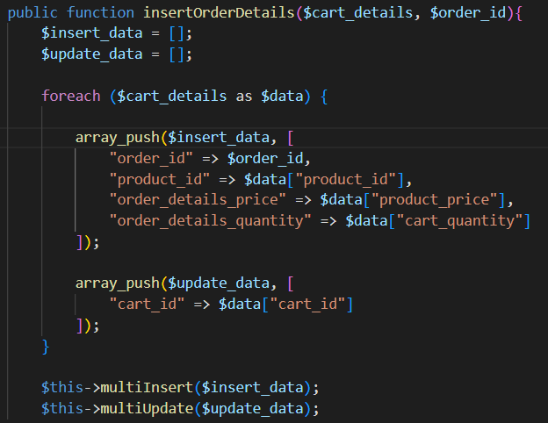

*Figure 37: Snippet of Code for Insertion function*

Items can also be removed from the cart by use of a similar function. This function exists both on a Model and Controller basis to ensure customers are not charged for items they did not intend to buy. The function that executes this requirement can be seen in Figures 38 & 39 below.

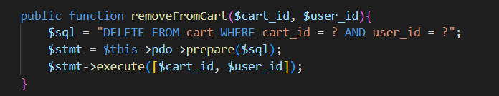

*Figure 38: Snippet of Code To Remove From Cart I*

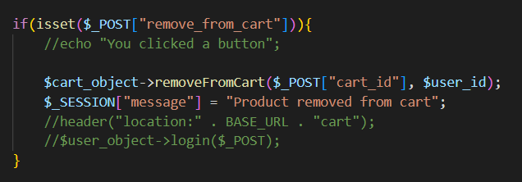

*Figure 39: Snippet of Code To Remove From Cart II*

**Product Inventory Management**

From an administrative perspective, product inventory is important as the goods available for purchase will be constantly changing with the market in terms of availability as well as supply and demand. It is also crucial to know how many of each item is stocked so that a customer does not purchase an item that is sold out for example. The products can both be edited through the MySQL Workbench as shown in Figure 40 below, as well as through the Admin Inventory Dashboard to be implemented.

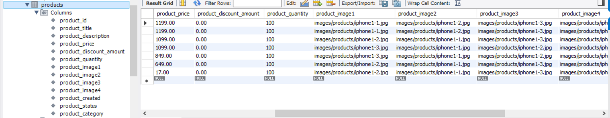

*Figure 40: Products Table in MySQL*

**Product Filtering Tool**

Given the wide expanse of products that are potentially available for purchase, a filtering tool would prove essential in helping a customer locate the item they are looking for. This can be done using the unique product ids assigned to each product and using a subcategory of classes by which each product can fit into.

**Customer Ratings**

While not crucial to the functioning of the application, this does enhance the user experience by allowing customers the opportunity to see what past buyers of a product thought about it. This could prove useful when comparing similar items and is done using a 5 star system, where the rating of each product is an aggregate average of all the ratings left on it from 1-5.

**Customer Profile Ratings**

Provided the public listing feature of the application, users would likely want to know how trustworthy a specific user is when purchasing an item from them. This prevents fraudulent activity and contributes to the trustworthiness of the site. This can be done by a badge network where a Seller’s profile achieves a higher rating for subsequent successful sales completed, and a lower rating when there are issues in the transaction process between two users.

**Best Sellers Page**

This is a handy feature to have so that customers can know at a glance what are the most popular items up for sale. This can influence the availability of the market, as users will be incentivised to list particular items they may have on hand if they know they are selling well, and items can gain momentum in terms of turnover if the quality of the product is exemplary.

### 6.4.2 Advanced Features Implemented

**Online Payment**

Stripe was used to allow a customer to pay online using a credit card or Google Pay. This was done using the HTML and CSS available on stripe.com, which also processes the transaction bearing the customer’s safety and privacy in mind.

Depicted in Figure 41 below is a snippet of the Stripe checkout Controller which facilitates ease of function when paying online, and the subsequent Figure 42 shows the actual Stripe Checkout Page.

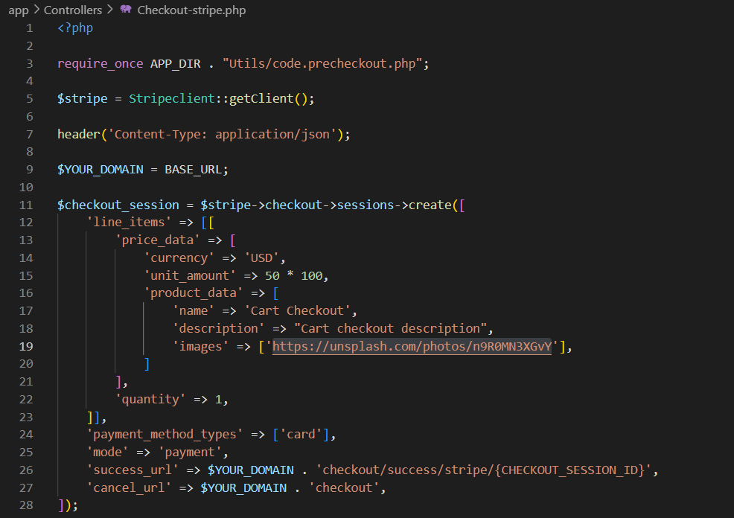

*Figure 41: Snippet of Code showing Stripe Checkout Functionality*

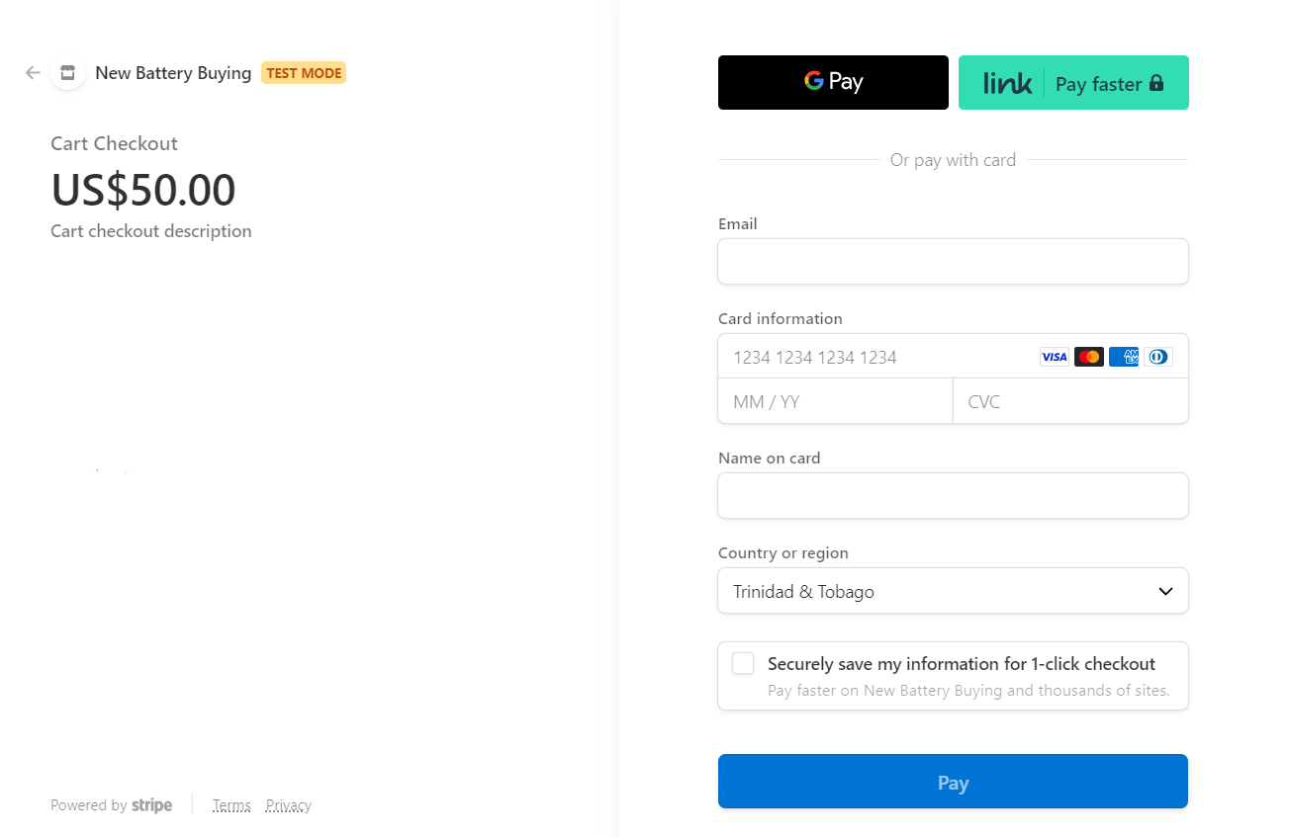

*Figure 42: Screenshot of Stripe Credit Card checkout*

**Referral Program**

This is used to bolster the user base by rewarding customers for encouraging people they know to shop on the site. This can be done by implementing on the registration page an optional input field labelled ‘Referred By’ where an already registered user’s email is entered upon creating an account. This ties into the gamification aspect of the artefact wherein discounts or credits will then be awarded to both the referrer and person who was referred.

**Gamification**

While not essential, this feature will further incentivise user engagement by awarding in-site credits for completing certain actions such as completing multiple purchases or posting a listing. This encourages the secondary market of the site in enriching the user posted items as well as making the process more entertaining and interesting to regular users. If customers who have already made and completed the order for which they came to the site, they feel compelled to spend more time browsing items or making additional purchases/actions if they have accreditation points from the system rolled over.

There is a point column in the users database that tracks users' points for each purchase. The current points in the users table are then updated with the new points. A fixed percentage of the total cost of the cart is represented by the points added to the users table. Before making a purchase, the user may put all of their points toward a discount.

**Analytics**

Ecommerce analytics entails the presentation of e-commerce statistics that may be used to learn more about the application usage and sales, allowing a business to base choices on the information at hand. It can also be used to inform suppliers of the supply/demand relationships of their products and can influence what items are thus imported wholesale as a byproduct. PowerBI can be utilized to implement analytics on the website. PowerBI is used to connect to the backend database and build a live report. To replicate a real reporting dashboard due to the limitations of creating the application locally, a sample dataset was utilised.

**Responsive Design**

A responsible quality of artefact design is ensuring that the application is user-friendly regardless of the device it is accessed on. This means that the success of an application depends on its ability to be accessed from a variety of devices and having a good UI/UX experience on each of these devices. To guarantee that different devices with varying screen sizes may access the program without any issues, responsive design must be integrated in the application. To guarantee that components on the screen grow, shrink, expand, or move to suit the screen they are displayed on, this capability would be added using CSS and HTML.

**Artificial Intelligence Chatbot**

The chatbot may help customers rapidly locate items by offering all users 24-hour support. The IntelliTicks chatbot was integrated into the application due to the difficulty of installing a custom-built chatbot as well as a lack of resources and expertise. The fully integrated AI chatbot IntelliTicks has customisable welcome messages, questions, and responses, URL redirection, and more. JavaScript code from IntelliTicks was used for integration into the artefact; it was included to the footer.php page and the chatbot.php page. Due to the footer area appearing on the majority of application web pages, duplication was reduced.

## 6.5 Security Consideration

Any software program must have security in order to protect itself against malicious attacks that might result in phishing and the disclosure of personal information.

Because this software will only be used for academic purposes and won't be accessible through the internet, several security issues, such as Sensitive Data Exposure, XML External Entities, Logging and Monitoring, may not apply. As a result, the artefact now includes mitigations for more pertinent areas, such as input checks and access control. As mentioned prior, user passwords are both hashed before storage in the database, and also masked on the screen upon input as indicated by Figures 43 and 44 below.





*Figures 43 & 44: Snippet of Password hash and example of stored password in Database User Table*

## 

## 6.6 Error Messages

According to Nielsen’s (1990) Heuristics, easily digestible and actionable error messages are vital to both the user and developer experience as it provides a sense of direction in the case of any unexpected malfunctions. Being a first-time academic endeavour, there are not as many resources toward troubleshooting such as 24/7 customer support or FAQ sections, but attempts were made to inform users of the error at hand. Instances of such are described and displayed in the Figure 45 following.

Should the application, for any reason, be unable to establish or maintain a connection with the database, on on-screen prompt will be displayed in the form of the getMessage echo “Connection failed”

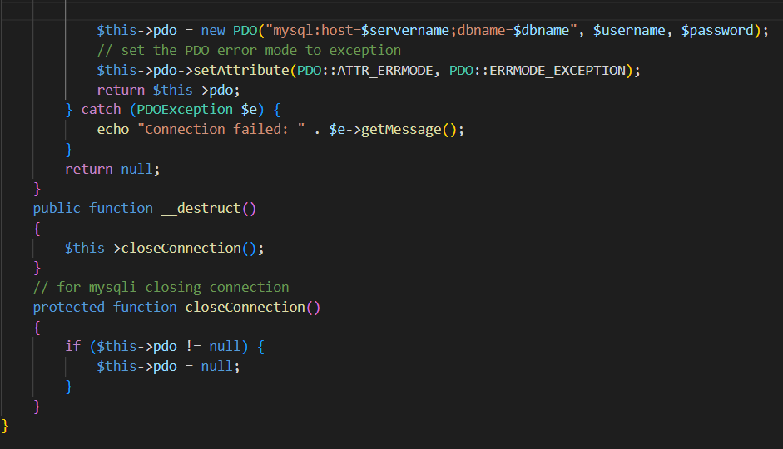

*Figure 45: Snippet of Code for Failed Connection to Database*

There is an implicitly embedded error message in the Checkout-success.php Controller that informs the user if for any reason their payment could not be processed which then automatically redirects them to the Cart page. The error message of “Payment process was not completed is shown in Figure 46 below.



*Figure 46: Snippet of Code for incomplete payment process*

If the User attempts to proceed to Checkout without any items in the Cart the page will reflect as such with a working hyperlink to take them back to the Store page so that they may add items to the Cart as evidenced in Figures 47 and 48 below.

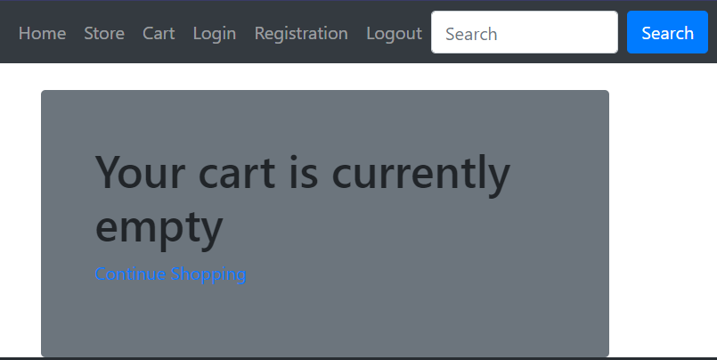

*Figure 47: Screenshot of Artefact with an Empty Cart*

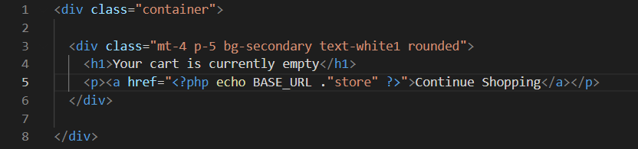

*Figure 48: Snippet of Code showing empty cart function*

Should the User try to Login using an email or password that wasn’t registered to the database, the application denies access to the Store page and instead shows an alert at the top of the Login page informing the User as such. See Figure 49 below

This is done by use of an alerts.php View as referenced in the code in Figure 50 & 51 below.

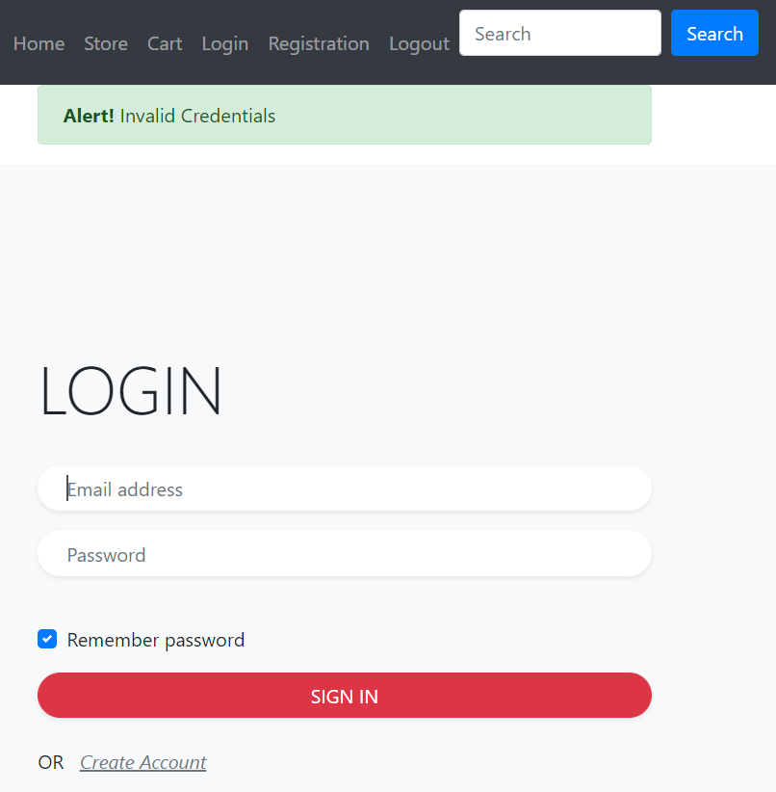

*Figure 49: Screenshot of Alert indicating invalid Login Credentials*

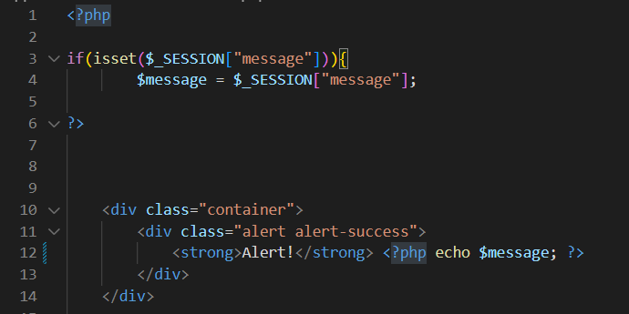

*Figure 50: Snippet of Code for Alert function*

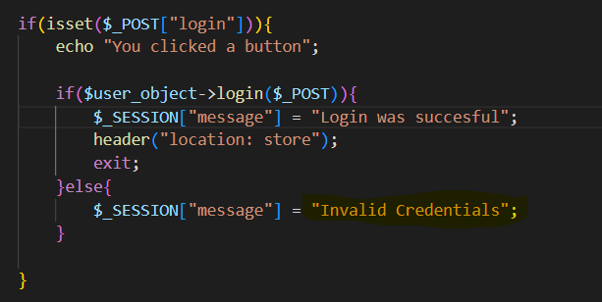

*Figure 51: Snippet of Code for informing user of Invalid Credentials*

The Stripe-helper.php model is session-based wherein a user attempts to make a payment but for some unknown reason the Stripe client cannot be accessed, or there is an error in the validation of the session. The display will inform the user that the API key is the problem in the former case as shown in Figure 52 below; and will simply depict a generalised error in the latter case - also shown in Figure 52 below.

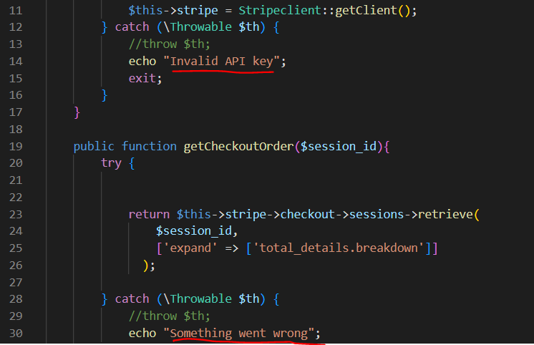

*Figure 52: Snippet of Code showing error messages for Stripe client*

If any fields are ignored in the input process, a pop-up will alert the user that there is still a field to be filled as seen in Figure 53 below

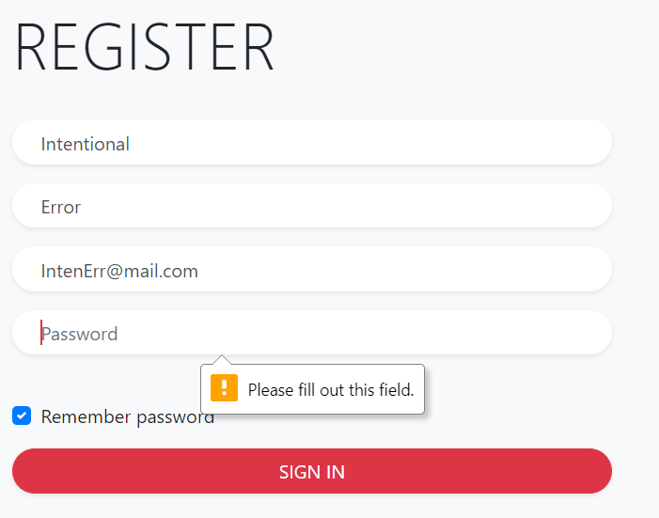

*Figure 53: Screenshot depicting pop-up of incomplete input field*

Any other auxiliary Errors are handled by the 404.php view which is standard for all web pages that cannot fulfil a web page request on the User’s part as shown in Figure 54 below.

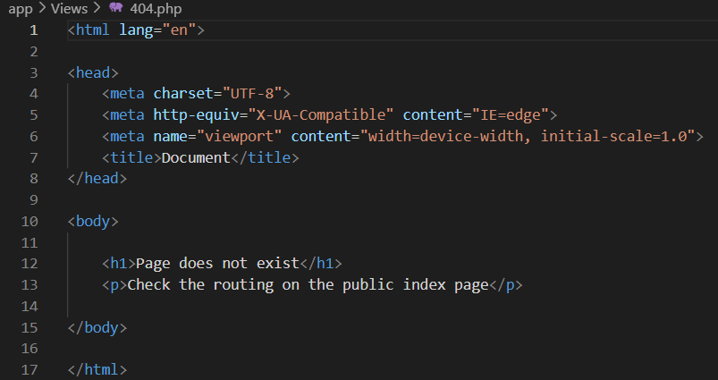

*Figure 54: Snippet of Code for 404 Page*

## 6.9 Version Control

Version Control is extremely important in the development cycle due to the uncertain nature of application construction. It allows for freedom and peace of mind when testing and troubleshooting to ensure large amounts of progress are not undone in the process. It also permits the reversion of changes and comparison to prior iterations of code so that experimentation can be done and contributes to the agile nature of the development process.

As mentioned previously, Visual Studio Code has a useful built-in support and extension for GIT version control which made the process simple, allowing for convenient and frequent back-ups to be made to an online cloud-like repository. Figures 55, 56 & 57 below show the log for this application’s Version Control.

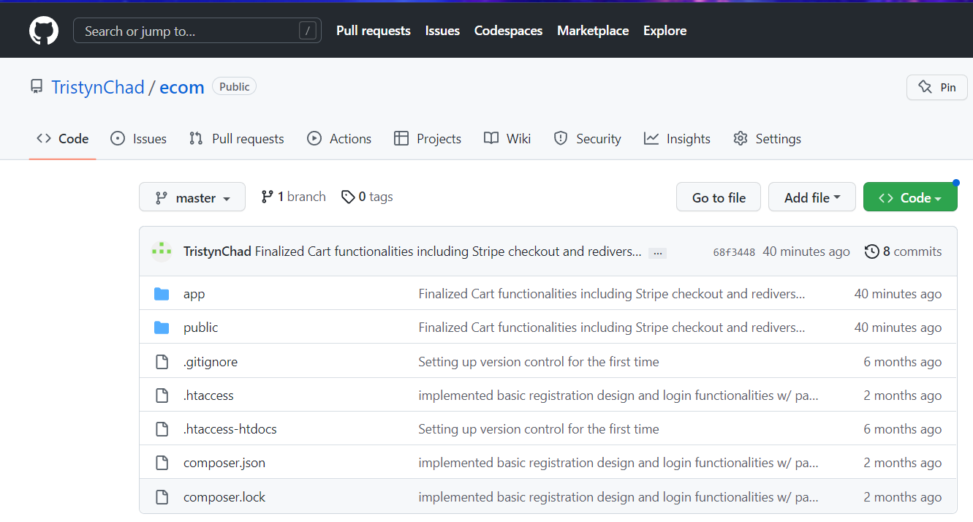

*Figure 55: Screenshot 1 of Git Repository*

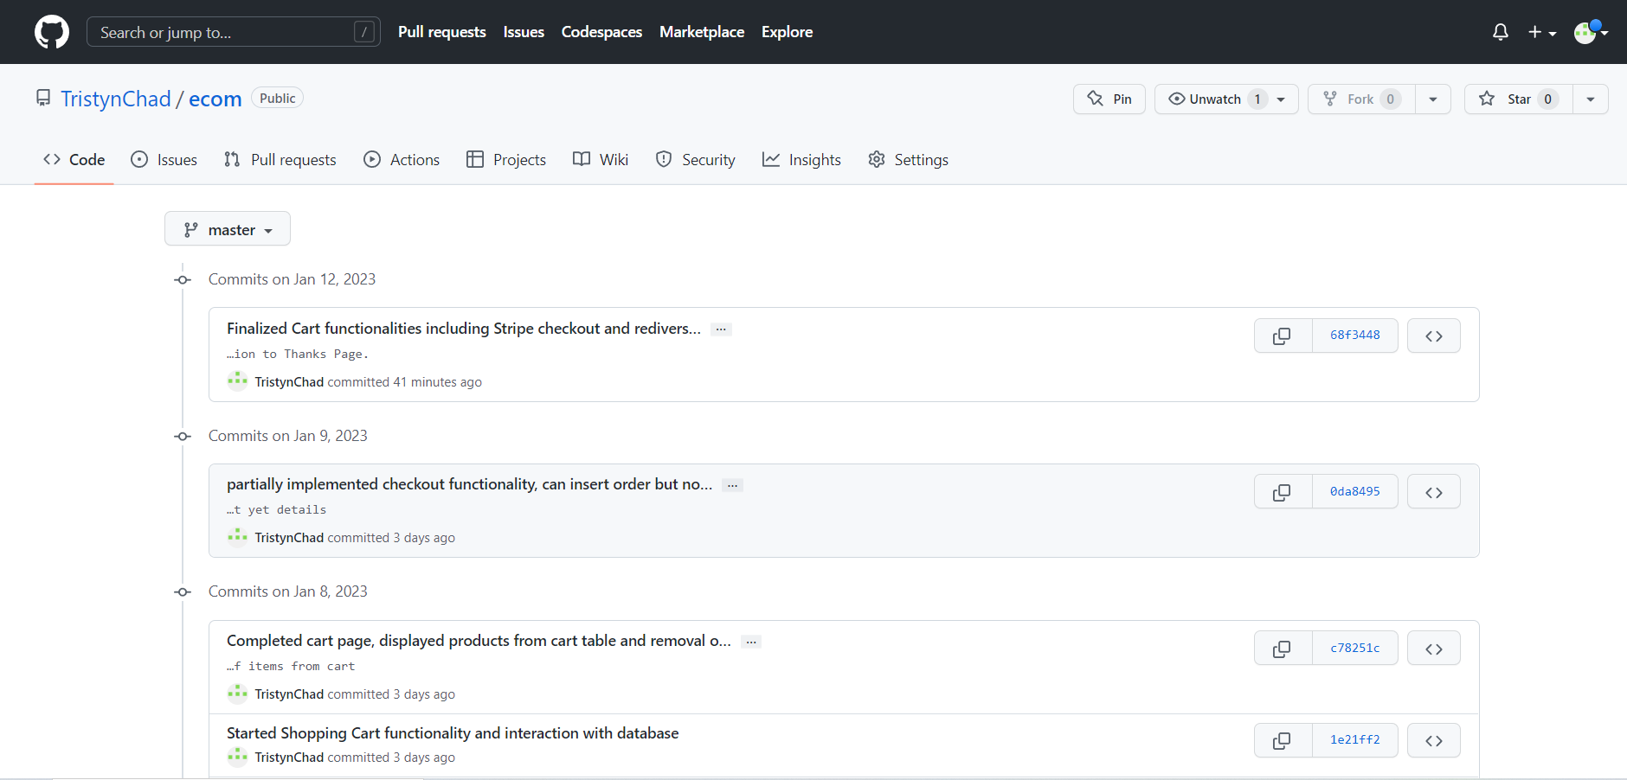

*Figure 56: Screenshot 2 of Git Repository*

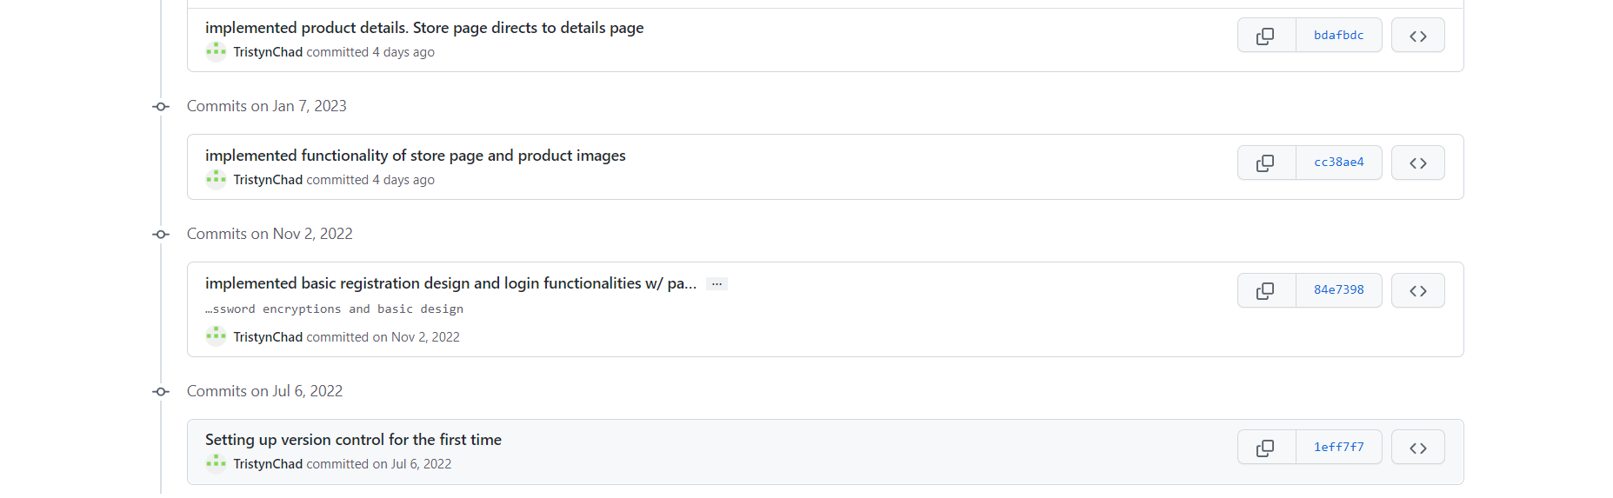

*Figure 57: Screenshot 3 of Git Repository*

## 6.10 Features Not Implemented

FR14 - Recommender System was not fully implemented due to time constraints and the complex nature of the functionality which would likely see a time-consuming amount of meta-data added to each individual ‘product’ in the database. Such advanced functionalities are usually executed by involved software development teams as opposed to a tertiary academic project with minimal funding.

# CHAPTER 7: TESTING

## 7.1 Introduction

Testing is important because it ensures that the program is carrying out the intended functions and that it is not doing anything unauthorised, improving the system's quality, dependability, and performance. The total risk level of a system is decreased by a well-designed test that passes. When faults are found during testing and fixed, the software system's quality increases. This further bolsters confidence in the system not only on the developer’s end, but the user’s and potential stakeholders as well.

This chapter deals with the testing of the system's functional and non-functional requirements. Each test that was run and the data that would be used, if possible, were listed in the test plan. The test document contained a record of the outcomes. Defects were recorded in a defect log, which provided the foundation for problem fixes after testing.

## 7.2 Test Plan

A set of tests will be created as part of the test strategy and executed on the application. Both functional and non-functional factors will be taken into consideration while evaluating the application. The functional requirements will be tested using a combination of unit and integration tests. Unit tests will use information like expected, boundary, and negative cases to make sure that the system's smallest parts handle known input and outputs correctly. The websites and database were tested as part of the integration test to make sure that all the parts work well together.

## 7.3 Functionality Testing

Table 10 & 11 below depicts the testing of Functional Requirements listed previously with testing data and subsequent results.

| Test ID | Test Using Data | Anticipated Outcome | Actual Outcome | Result |
| --- | --- | --- | --- | --- |
| FR 1.1 | No information entered into input fields | A pop-up message showing that information is missing from fields | Worked as expected | Success |
| FR 1.2 | Register customer Keanu Reeves with email address [kreeves@mail.com](mailto:kreeves@mail.com) and password: Donttouchmydog1 | A successful account creation notice and a link to the login page were sent to the customer after registration. In the users table, a record for customers has been added. | Worked as expected | Success |
| FR 1.3 | Register customer James Bond with email address [kreeves@mail.com](mailto:kreeves@mail.com) and password:  Donttouchmydog1 | System informs user that the email address entered already exists and provides link to the Login Page | Worked as expected | Success |
| FR 1.4 | Register customer Jason Bourne with email address [jbourne@mail.com](mailto:jbourne@mail.com) and password: jasonb | A message indicating that the password is not strong enough and a request should be posed to the user to enter a new one. Included should also be a brief description of what qualifies as a strong password. | Worked as expected | Success |
| FR 1.5 | Register user Micheal Scott with email address [dundermifflin@mail.com](mailto:dundermifflin@mail.com) and password tlevelmidnight1,  Confirm password as:  tlevelmidnight2 | A message should be shown to the user indicating that the Password and Confirmed password are not the same. | Worked as expected | Success |

*Table 10: Functionality Testing using data*

| **Test ID** | Test Using Data | Anticipated Outcome | Actual Outcome | Result |
| --- | --- | --- | --- | --- |
| **FR 1.6** | Login without entering information in the input fields | A pop-up message saying the input sections are missing information | Worked as expected | Success |
| **FR 1.7** | Login using pre-existing account info of email address [kreeves@mail.com](mailto:kreeves@mail.com) and password:  Donttouchmydog1 | Successful Login Alert appears in the page header and the user is redirected to the Store page. A record is logged in the users table of the database | Worked as expected | Success |
| **FR 1.8** | Login using email address [kreeves@mail.com](mailto:kreeves@mail.com) and incorrect password: Donttouchmydog2 | The Login does not proceed and the system alerts the user that they have entered invalid credentials | Worked as expected | Success |
| **FR 1.9** | Attempt to visit Login Page while already logged in | Reroutes user to the Store Page | Worked as expected | Success |
| **FR 2.1** | A logged in User clicks ‘Add To Cart’ on the Details page of an item | The item is added to the user’s Cart page and the price of the item is added to their Cart Total | Worked as expected | Success |
| **FR 2.2** | A logged in user with an item in their Cart clicks the ‘Remove’ button under the item in the Cart Page | The item is removed from the user’s Cart and the price of the item is deducted from their Cart Total | Worked as expected | Success |
| **FR 2.3** | A logged in user with an item in their cart clicks the arrow to alter the quantity of the item increasing it by one | The quantity of the item in the Cart increases by one and the amount in their Cart Total updates to reflect this change | Worked as expected | Success |
| **ADV FR1** | Online Payments using Stripe | A user signs in and adds Product 1 to their shopping cart. The customer chooses checkout. The customer inputs a test credit card number on the checkout page. The payment is completed when the checkout is processed. Items in the cart are updated and then deleted. | Worked as expected | Success |
| **ADV FR2** | Gamification & Referral | A user inputs [kreeves@mail.com](mailto:kreeves@mail.com) in the Referral section after Registration. Both users now have accrued points in the base system that can be used for discounts and benefits | Worked as expected | Success |
| **ADV FR3** | ECommerce Analytics | An admin User logs in and navigates to the Analytics section. They select a User Profile and determine what is the most frequently purchased item from that User | Worked as expected | Success |
| **ADV FR4** | Responsive Design | The application is access using a mobile emulator such as BlueStacks to ensure functionality on a mobile device | Worked as expected | Success |
| **ADV FR5** | Artificial Intelligence Chatbot | The user enters a text prompt asking the AI chat bot what is the cheapest version of the item they are currently viewing | Needs additional implementation | Partial Success |

*Table 11: Functionality Testing using data*

## 7.4 Non-Functionality Testing

A set of tests were implemented and the results logged for non-functional requirements that would be assessed, similarly to the functional requirements. Table 12 below depicts the testing of the non-functional requirements

| **NF ID** | NF Requirement | Test Details | Anticipated Outcome | Actual Outcome | Result |
| --- | --- | --- | --- | --- | --- |
| **NFR-1** | Browser Compatibility | Application was to be opened in multiple browsers including Google Chrome, Firefox, Opera, and MS Edge | Consistent display and functionality across all browsers | Works as intended | Success |
| **NFR-2** | Application Security /Encryption | Attempted creation of an account with a weak password  &  Admin tries to access password from Database and login using corresponding email address | Registration proves to be unsuccessful as an alert will pop up indicating that a stronger password must be used  &  Actual password cannot be found due to it being hashed before storage in the Database | Works as intended | Success |
| **NFR-3** | Database Security | Penetration Testing unavailable due to local hosting as opposed to being a public domain | N/A | N/A | N/A |
| **NFR-4** | Availability/Reliability | Implies the uptime guaranteed by the software, also cannot be tested due to the site being locally hosted and not part of the public domain | N/A | N/A | N/A |
| **NFR-5** | Scalability and Performance | Would entail an increased traffic flow to the site by external users, wherein website ping and speed would be tested accordingly. Cannot be tested due to the application being locally hosted and not part of the public domain | N/A | N/A | N/A |
| **NFR-6** | Maintainability | The ease with which products can be added or removed from the catalogue would be assessed | Products are quickly and efficiently added and removed from both database and Store page | Works as intended | Success |
| **NFR-7** | Usability | Assessment of Heuristic evaluation including user freedom and control, relevant and consistent names and features across the application, similar elements shared by other ecommerce applications, visibility of system status etc. | Even less technologically inclined users can intuitively use the site’s main features | More attention needed toward consistency of appearance | Partial Success |
| **NFR-8** | Consistency | The practical design aspects of the system should result in a consistent look/feel of the application which includes user inputs and interactions across the application as well as layout and site element uniformity | There is an overarching theme to the site which is in line with the overall design philosophy | Works as intended | Success |

*Table 12: Non-Functionality Testing using data*

## 7.5 Defects Log

This log is used to track difficulties, flaws or faults encountered during testing. It is used as a record for earlier assessments that are not up to standard and indicates items that could use improvement by use of Severity Ratings:

Severity of Defect Key:

* 0 - Not a problem
* 1 - Purely cosmetic issue: should only be focused on if time permits
* 2 - Minor problem: Low priority repair, somewhat related to non-core functionality
* 3 - Major Problem: High Priority resolution, related to core functionality of application

Table 13 below shows the Defects Log alongside the Severity Rating and commentary associated.

| **Entry #** | **Test ID** | **Requirement** | **Problem** | **Severity Rating** | **Comment** |
| --- | --- | --- | --- | --- | --- |
| 1 | ADV FR5 | Artificial Intelligence Chatbot | Needs additional functionality | 2 | Due to the complex nature and limited time constraints, the AI Chatbot is not as robust or intelligent as a platform like this would require, as it pertains to the sheer breadth of potential queries by a user |
| 2 | NFR-7 | Usability | Website is not as polished or refined as a typical ecommerce website | 1 | There are a wide variety of cosmetic and design features available that could have been implemented but were not due to time and resource constraints |

*Table 13: Defects Logs*

## 7.6 Analysis of Test Results

After summarising test results, it was concluded that twenty-four (24) of the twenty-six (26) were conducted successfully. As per a lack of development time, these defects were not amended - but were not of a high enough Severity Rating to present an obstacle to the proper functioning of the application and would only be observed under heavy scrutiny.

# CHAPTER 8: EVALUATION

## 8.1 Introduction

The artefact underwent extensive evaluations in addition to testing to confirm its viability in achieving the objectives of improved sales and customer loyalty. This chapter will go through the many techniques used to effectively assess and quantify usability problems that might have a negative impact on users, lead to an increase in complaints, and affect conversion and retention objectives. Additionally, the focus of this chapter is "how well does it work?" rather than "whether or not the program works" as that was covered in the prior chapter. This chapter focuses on applying a heuristic evaluation to rate the usability of the application.

Additionally, it will display the outcomes of the heuristic evaluation measures performed on the application using a checklist created in accordance with Nielsen's Heuristics guidelines as well as any suggestions for ongoing improvement that were based on these reviews and put into action to enhance the user experience.

## 8.2 Method of Evaluation

Although there are various evaluation techniques, a heuristic evaluation is being utilized for this application because of the project's time constraints and the academic approach used, constricts testing on subjects who have passed an ethics clearance process. The lack of subjectivity in this method is a disadvantage since it is not necessary to be able to measure customer contentment.

## 8.3 The Heuristics

The 10 usability criteria from Nielsen and Molich(1994), which were outlined in the report's Design chapter, served as the basis for the heuristic evaluation used for this project.

For each item on the checklist, the evaluation will determine if the heuristic was not used, either partially applied, or fully applied throughout the whole application. In order to represent the outcome, a rating was used, with zero (0) denoting that the heuristic was not used. One (1) indicates that the heuristic has only been partially applied, whereas two (2) indicates that it has been fully applied.

* **0** implies the heuristic was **not implemented**
* **1**  implies the heuristic was  **partially implemented**
* **2**  implies the heuristic was **fully implemented**

Table 14 below, using Neilsen’s 10 Heuristic Principles, shows the evaluation of the system

| 1. **Visibility of System Status** | | | |
| --- | --- | --- | --- |
| No. | Review Checklist | Rating | Comment |
| 1.1 | Does every display have a title or header that introduces the contents of the screen? | 2 |  |
| 1.2 | Do all menu prompts, instructions, and errors display in the same location(s) on each menu? | 2 |  |
| 1.3 | Is the icon design and stylistic treatment uniform throughout the system? | 2 |  |
| 1.4 | Does the system employ context labels, menu maps, and location markers as navigational assistance when users have to switch between various screens? | 2 |  |
| 1.5 | Is there visual feedback indicating which alternatives have previously been picked in a menu or dialog box when many options are available? | 2 |  |
| 1. **Match Between System and The Real World** | | | |
| No. | Review Checklist | Rating | Comments |
| 2.1 | Are symbols real and recognizable? | 2 |  |
| 2.2 | Has the natural order of menu options been used, if there is one? | 2 |  |
| 2.3 | On the same screen, do related and dependent fields appear? | 2 |  |
| 2.4 | Do the chosen colours match what people often expect from colour schemes? | 2 |  |
| 2.5 | Are the words in the message congruent with the action suggested by the prompts? | 2 |  |
| 2.6 | Is user jargon used instead of computer jargon in the command language? | 2 |  |
| 2.7 | For monetary entries, does the system automatically enter a dollar symbol and decimal? | 2 |  |
| 2.8 | Does the system always add commas after numbers bigger than 999? | 0 | Not entirely necessary |
| 1. **User Control & Freedom** | | | |
| No. | Review Checklist | Rating | Comments |
| 3.1 | Does the system wait for a signal from the user before processing when a user job is finished? | 2 |  |

| 3.2 | Are consumers asked to confirm orders that have grave, damaging repercussions? | 2 |  |
| --- | --- | --- | --- |
| 3.3 | Can users choose an item from large menu lists (those with more than seven items) by moving the mouse over it or by entering a mnemonic code? | 0 | Deeply involved code/programming |
| 3.4 | Can users navigate back and forth between every page in a series of multipage data entry panels on the system? | 2 |  |
| 1. **Consistency and Standards** | | | |
| No. | Review Checklist | Rating | Comments |
| 4.1 | Has a screen's extensive usage of capital letters been avoided? | 2 |  |
| 4.2 | Are real numbers decimal aligned and integers right justified? Do icons have labels? | 2 |  |
| 4.3 | Do icons have labels? | 2 |  |
| 4.4 | Does each window have the ability to scroll both vertically and horizontally? | 2 |  |
| 4.5 | Are menu option lists displayed vertically? | 2 |  |
| 4.6 | Are there only four to seven colours at most, and are they spread out widely over the visible spectrum? | 2 |  |
| 4.7 | Is the use of intense blues for text or other fine-lined, tiny symbols avoided? | 2 |  |
| 4.8 | Does every page of the system's multipage data input screens have the same title? | 2 |  |
| 1. **Help Users Recognize, Diagnose, and Recover From Errors** | | | |
| No. | Review Checklist | Rating | Comments |
| 5.1 | Are instructions given in a positive manner, without any explicit or implying criticism of the user? | 2 |  |
| 5.2 | Does using prompts suggest that the user is in charge? | 2 |  |
| 5.3 | Are prompts succinct and clear? | 2 |  |
| 5.4 | Are error messages written in proper grammar? | 2 |  |
| 5.5 | Do the error messages abstain from the use of exclamation points? | 2 |  |

| 5.6 | Do error messages refrain from using harsh language? | 2 |  |
| --- | --- | --- | --- |
| 5.7 | Does the system place the cursor in a data entry field when an error is found there or does it highlight the error instead? | 2 |  |
| 5.8 | Do error messages allude to the root of the issue? | 2 |  |
| 5.9 | Do error messages specify what the user should do to fix the issue? | 2 |  |
| 1. **Error Prevention** | | | |
| No. | Review Checklist | Rating | Comments |
| 6.1 | Does the software try to stop users from making mistakes? | 2 |  |
| 6.2 | When a user is going to commit a potentially harmful error, does the system alert them? | 2 |  |
| 6.3 | Do conversation boxes and data entry windows show how many character spaces are there in a field? | 0 | Deeply involved programming/ Not entirely necessary |
| 1. **Recognition Rather Than Recall** | | | |
| No. | Review Checklist | Rating | Comments |
| 7.1 | Are messages, signals, and prompts positioned on the screen where the eye is most likely to be directed? | 2 |  |
| 7.2 | Are there "breathing spaces" surrounding text areas? | 2 |  |
| 7.3 | Is white space utilised to provide symmetry and guide the eye in the right way? | 2 |  |
| 7.4 | Have objects been logically categorised into zones, and have headings been utilised to demarcate the zones? | 2 |  |
| 7.5 | Do zones have a maximum width of twelve to fourteen characters and a maximum height of six to seven lines? | 0 | Deeply involved programming/ Not entirely necessary |
| 7.6 | Are field labels near to the fields but at least a gap apart? | 2 |  |
| 7.7 | Is the system's use of colour coding uniform throughout? | 2 |  |

| 7.8 | Do the colours of the backdrop and the image have a nice colour and brightness contrast? | 2 |  |
| --- | --- | --- | --- |
| 1. **Flexibility and Minimalist Design** | | | |
| No. | Review Checklist | Rating | Comments |
| 8.1 | Are menu titles concise but descriptive enough? | 2 |  |
| 8.2 | Does each symbol stand out from the surrounding material? | 2 |  |
| 8.3 | Are field labels succinct, well-known, and descriptive? | 2 |  |
| 8.4 | Has the title of each data entry screen been kept brief, plain, and distinct? | 2 |  |
| 1. **Aesthetic and Minimalist Design** | | | |
| No. | Review Checklist | Rating | Comments |
| 9.1 | Is just (and only) information presented on the screen that is necessary for making decisions? | 2 |  |
| 9.2 | Do each icon in a set have a unique appearance and meaning? | 2 |  |
| 9.3 | Does using prompts suggest that the user is in charge? | 2 |  |
| 9.4 | Are error messages written in proper grammar? | 2 |  |
| 9.5 | Do prompts employ the active voice and are they affirmatively expressed? | 2 |  |
| 9.6 | Do error messages allude to the root of the issue? | 2 |  |
| 9.7 | Do error messages refrain from using harsh language? | 2 |  |
| 1. **Help & Documentation** | | | |
| No. | Review Checklist | Rating | Comments |
| 10.1 | Are the visual cues in online instructions clear? | 2 |  |
| 10.2 | Navigation: Is it simple to discover the information? | 2 |  |
| 10.3 | Presentation: How well-designed is the visual layout? | 2 |  |
| 10.4 | Conversation: Is the data correct, comprehensive, and easy to understand? | 2 |  |
| 10.5 | Is the information pertinent? | 2 |  |
| 10.6 | Goal-oriented (What are the uses for this program?) | 2 |  |
| 10.7 | Descriptive (What is the purpose of this?) | 2 |  |
| 10.8 | Descriptive (What is the purpose of this?) | 2 |  |

*Table 14: Nielsen’s Heuristic Evaluations*

## 8.4 Summary of Findings

The Heuristic Report is displayed below. It is the product of the Heuristic analysis. The list had sixty things, three of which were not carried out. The Heuristic Report is displayed in Table 15

| Entry | Test # | Review Checklist | Severity | Comment |
| --- | --- | --- | --- | --- |
| 1 | 2.8 | Does the system always add commas after numbers bigger than 999? | 1 | This is low priority and will only be addressed if the project timeline permits |
| 2 | 3.3 | Can users choose an item from large menu lists (those with more than seven items) by moving the mouse over it or by entering a mnemonic code? | 1 | This will only be addressed if the project timeline permits |
| 3 | 7.5 | Do zones have a maximum width of twelve to fourteen characters and a maximum height of six to seven lines? | 1 | This will only be addressed if the project timeline permits |

*Table 15: Heuristic Report*

## 8.5 Analysis of Results

Of the sixty things on the check list, fifty-seven were entirely completed, according to the Heuristic Report's conclusions. The three violations were addressed. B eing modest and not endangering the use of the program, the three deflects were not fixed because of a lack of time and expertise.

# CHAPTER 9: CONCLUSION

## 9.1 Introduction

The student is required to undertake a complex individual project; which is an academic exercise based on the development of a practical artefact which includes the construction of a substantial technical dissertation. The reflective section of the project is a culmination of the work done and experiences learned during the project development . This chapter highlights my achievements and what I would do differently given I had to develop the project again. This chapter in addition takes a critical outlook of the software artefact and the project plan.

## 9.2 Tasks Completed

As evidenced in the Requirements chapter, 20 of the 22 requirements were implemented. This was due to irresponsible time-management on my part as well as a lack of expertise. The partially implemented features did not drastically affect functionality or stability of the application, but having completed them would have made for a more holistic realisation of the vision I had for this project. Of the two I wish I could have spent more time on I would include 1) Artificial Intelligence Chatbot and 2) Recommender Systems as I believe they could have been more functionally executed. Nevertheless I believe the artefact was up to standard and I am pleased with the system I intend to demonstrate for UoB.

## **The Project Plan**

The project plan was made to serve as a roadmap, making it simple for me to decide which activities to focus on at any given time to ensure that the project is successfully finished. The project seemed much more manageable because it was divided into smaller, more manageable pieces. The project has become more precise as a result, and I can now better manage my day by concentrating on a smaller, more focused activity that, when completed, will help me complete a larger one.

When I first started the project, I thought everything would go smoothly, but as I worked on it, I found that I had miscalculated how long various chores would take to do. This gave me mixed feelings of frustration and pessimism, but also bolstered my drive to see the project to fruition.

The strategy undoubtedly assisted me in reaching my goals. I was able to focus on the important things because of the fixed deadlines. I was unable to meet certain of the programming components' due dates, which were specified in the project plan, however. I had grossly underestimated the work required which did not pair well with my novice experience in some of the programming languages.

I believe that having a plan helped since it made it clear what I should be doing at any given time. The jobs I wasn't able to do by the deadline weren't well planned for due to the high learning curve of the programming language.

I've discovered that project planning is not a precise science and that plans must change as a project advances rather than being set in stone.Some jobs I was able to complete earlier than I had anticipated, while others took me a lot longer to achieve. By altering the schedules and providing extra time where it was necessary, I was still able to accomplish the targets. I now know that project management includes risk management as a crucial component.

The software prototype was where I spent the majority of my time due to the installation and configuration issues I had in the beginning. Additionally, I ignored the plan's recommendation to complete the application and report at the same time, which led to a feeling of overload when it came time to submit the reflective report. If the plan had received more attention, some of these feelings would not have surfaced, and I might have felt more in control.In the future, I aim to complete the remaining portions of the project by closely following the plan.

## **The Artefact**

It is realistic to expect that the software artefact will have some defects given the extensive list of deliverables and the 12-week time constraint assigned for project completion.

The website is modest in comparison to well-known ones like Amazon.com. However, the system has a lot of advantages for an academic project that was developed by a novice programmer. Database development, which follows a top-down approach, is one of the main strengths. To achieve third normal form, the tables were normalized. Update anomalies were avoided with a normalized database. The use of gamification aspects, recommender algorithm implementation, responsive design and a process funnel design pattern are a few more benefits. These features are present in the majority of e-commerce apps.

A weakness of the application is the demand for better design aesthetics. The application's impact may be boosted by employing expert photos, several images of a single product, and descriptions of the products that are conducive to marketing. Additional flaws include the emotional effect, context, and usefulness. According to the profiles created, the necessity for a one-click checkout would benefit customers who wish to purchase a single item but don't have much time available for protracted checkout procedures. Additionally, the application now requires users to register before they can add products to the cart. However, it would be preferable to allow users to add items to the cart first and register in order to check out the cart. This requirement is there to encourage users to shop.

Before being used by the broader public as third-party software, the program should preferably have some limitations. The use of a variety of payment options, including PayPal and cryptocurrency, as well as credit card integration. The ability to choose the size and colour of a certain item would be helpful, as well as more properly made images and videos. The application's resilience to security threats or high traffic volumes has not been fully assessed.

## **The Project Progress Reports**

I had my first chance to manage a project of this kind independently thanks to this module. I came up with the project concept on my own and conducted the necessary background research and analysis. Because I had no prior experience with a project like this, my supervisor's guidance and feedback were greatly aided by the project progress reports. Even though the text and PowerPoint examples in the guided learning were helpful, there weren't enough of them to fully grasp the specifics needed for the report's content. Due to my lack of programming knowledge, I frequently became upset because, despite completing research, I did not know how to go next. As a result, I would either focus on something else or go to sleep. My boss suggested that I devote an additional hour or two each day to the creation of the artefact after consulting with him. I came to the conclusion that I needed to devote more time to the artefact and spend less time on other activities like sleep and leisure. In order to finish the report and artefact on time, he also advised me to work on them both at the same time. As a result, more effective time management is required.

He counselled me on the value of being proactive in my project because it can influence how it develops. I was able to put his words of wisdom to action and promptly fixed this flaw. Since then, I've planned many meetings with him to go over what I've accomplished so far and where I need to go from here. The use of effective time management is one thing I learned through working on this project. I was able to juggle the time with my other obligations while maintaining the project's schedule. His direction and this project have both really aided me in keeping the project on track. My supervisor gives me sharp feedback on my work, and he gives me tips on how to improve and what the university wants at this level. When I compared my work to previous sample projects that had received high marks, I realised that his criticisms were actually meant to inspire me to use my time wisely and produce a project like that. He inspired and reassured me, and I feel more ready to face his criticism now that I know it will only be beneficial to me. I now know that my supervisor is here to help me reach my objectives by giving me advice and feedback. I've also discovered that anything is doable with good time management and an optimistic outlook.

## 9.3 Experiences Gained

**1.** **Academic Writing**

I have acquired the knowledge and abilities necessary to independently conduct research, formulate strategies, design solutions, and implement those solutions for a large computer science issue through this project. The project unit calls for the creation of a number of technical reports, each of which must contain a reasoned exposition of knowledge and make critical use of relevant published resources as well as literature. I have to improve my academic writing abilities for this.This approach involves gathering relevant sources, seeing connections between relevant ideas, and synthesising a wide range of thoughts.. These reports were produced in large part by critical academic writing and critical thinking.

**2.** **Project Management**

I realised how important it was to have a plan in order to successfully complete my assignment.. Over the course of the project, the plan changed. In particular, having a clear plan enabled me to see the impractical nature of the initial anticipated implementation timeframes at an early stage. This was primarily due to my underestimating the amount of time required to learn and use the new languages and technologies that I had chosen to use in my project. Initially, I had planned to study PHP, HTML, CSS, and SQL concurrently with system development. This turned out to be impossible because I had to learn a certain amount about these technologies before I could start implementing them.

**3.** **Communication Skills**

Communication abilities, both verbally and in writing, are highly critical in the success of the project. I had to speak with my supervisor on the phone quite a bit. Because I had to finish several reports for this course and was preparing to write a lengthy technical report that reviewed the work done, it was very crucial for me to be able to write coherently.

**4. Coding and Software Development**

Programming-wise, because I've only recently been exposed to PHP, HTML, CSS, and SQL, I've learned a ton of code. Although I couldn't create an e-commerce site from the start, I can identify issues, troubleshoot them, and then use my expertise to repair them. I gained knowledge about building MySQL databases and tables and utilising the PHP programming language to connect, query, add, and remove data. I now know how to set up Visual Studio Work and use Git version control to back up my code to the cloud and quickly access previous versions of my code when needed. I think that if I spend more time understanding web and database programming, I will be able to contribute to many businesses that need people with knowledge of web technology. After I graduate, I want to continue working on my artefact and begin a few smaller projects.

I now understand the value of the software life cycle, particularly the methods used in the design phase. These include the use of the Entity-Relationship Diagram in database design and the significance of normalisation. The significance of the ten Nielsen's Usability Heuristics principles and how they might result in a standout artefact are also discussed. These design strategies have changed the way I've gone about putting the artefact into practice, and I'll always keep them in mind while working on new projects.

## 9.4 Product Built

Given the lengthy list of deliverables, the twelve-week deadline, and the challenging nature of the application and dissertation, it is reasonable to presume that the software artefact has some faults.

The application isn't nearly as sophisticated as well-known websites like eBay.com & Amazon.com, which employ a much larger team to design, implement, and test their application. Nevertheless, the software artefact has many benefits for an academic project carried out by a student with limited web development and programming experience. One of the main advantages is the database construction, which uses a top-down approach. By adopting a normalised database, update anomalies might be avoided. Other positives include the use of complex technologies like an AI chatbot, flexible design that enables the program to function on different screen sizes, and gamification components. Applications for eCommerce that are effective frequently have such functionalities.

An inherent problem with the application is the demand for improved design aesthetics.

There are issues with the context, emotional impact, and usefulness.

The effectiveness of the application may be increased by using professional images, several images for a single product, in addition to a product description that is suitable for marketing. In addition, the application currently requires users to register before they can add items to their cart in an effort to encourage users to shop; however, a better strategy would be to allow users to add items to their cart first and then allow them to register when they are ready to check out.

In a perfect world, third-party software used for public use would be subject to some limitations. Usability may be improved by including credit card payments together with a variety of other payment methods like PayPal and cryptocurrency. Since the application has not been properly tested to ensure that it can withstand security threats or high traffic volumes, it is not advised that it be put into use for the general public at this time. Yet, for the purposes and contexts related to an academic endeavour such as this, I believe the amount of work put in will suffice.

# 

# 10 References

1. Aggarwal, C.C., (2018). Recommender systems the textbook, Cham: Springer International Publishing.

2. Anon, (2019). How gamification can help an online store increase sales. Promodo online marketing company - SEM, SEO services, PPC, usability & CRO. Available at: https://www.promodo.com/blog/how-gamification-can-help-improve-ecommerce-marketing-performance/ [Accessed September 7, 2022].

3. Chakraborty, A., Baowaly, M.K., Arefin, A. and Bahar, A.N., (2012). The role of requirement engineering in software development life cycle. Journal of emerging trends in computing and information sciences, 3(5).

4. Coulon, F. et al., (2020). Modular and distributed ide. Proceedings of the 13th ACM SIGPLAN International Conference on Software Language Engineering.

5. Dawson, C. et al., (2015). The Pros and cons of utilizing agile methodologies. Nearshore Americas. Available at: https://nearshoreamericas.com/agile-methodology-advantages-disadvantages/ [Accessed September 5, 2022].

6. De Canio, F., Fuentes-Blasco, M. & Martinelli, E., (2021). Engaging shoppers through mobile apps: The Role of Gamification. International Journal of Retail & Distribution Management, 49(7), pp.919–940.

7. Engdahl, S., (2008). Blogs. Amazon. Available at: https://aws.amazon.com/blogs/security/importance-of-encryption-and-how-aws-can-help/#:~:text=AES%2D256%20is%20the%20technology,S3)%20server%2Dside%20encryption. [Accessed September 7, 2022].

8. Faithfull, A. et al., (2017). Coqoon. International Journal on Software Tools for Technology Transfer, 20(2), pp.125–137.

9. García, M.del, García-Nieto, J. & Aldana-Montes, J.F., (2016). An ontology-based data integration approach for web analytics in e-commerce. Expert Systems with Applications, 63, pp.20–34.

10. Gavrila Gavrila, S. and De Lucas Ancillo, A. (2022), "Entrepreneurship, innovation, digitization and digital transformation toward a sustainable growth within the pandemic environment", International Journal of Entrepreneurial Behavior & Research, Vol. 28 No. 1, pp. 45-66. https://doi.org/10.1108/IJEBR-05-2021-0395

11. Guilizzoni (2021) What are wireframes. Available at: https://balsamiq.com/learn/articles/what-are-wireframes/ (Accessed October 30 2022)

12. Gupta, A., (2016). Database Security of E-Commerce Based on Hybrid Encryption. International Journal of New Technology and Research, 2(4), p.263531.

13. Haaranen, L. & Lehtinen, T., (2015). Teaching git on the side. Proceedings of the 2015 ACM Conference on Innovation and Technology in Computer Science Education.

14. Hamari, J. (2013), “Transforming homo economicus into homo ludens: a field experiment on gamification in a utilitarian peer-to-peer trading service”, Electronic Commerce Research and Applications, Vol. 12 No. 4, pp. 236-245.

14. Hofacker et al., (2016), “Gamification and mobile marketing effectiveness”, Journal of Interactive Marketing, Vol. 34, pp. 25-36

15. Jari-Pekka Voutilainen, Jaakko Salonen, and Tommi Mikkonen. (2015). On the design of a responsive user interface for a multi-device web service. In Proceedings of the Second ACM International Conference on Mobile Software Engineering and Systems (MOBILESoft '15). IEEE Press, 60–63.

16. Jeeva, A.L., Palanisamy, D.V. and Kanagaram, K., (2012). Comparative analysis of performance efficiency and security measures of some encryption algorithms. International Journal of Engineering Research and Applications (IJERA), 2(3), pp.3033-3037.

17. Johansen, R.D., Britto, T.C. & Cusin, C.A., (2013). CSS browser selector plus. Proceedings of the 22nd International Conference on World Wide Web.

18. Kallumadi, S. et al., (2021). ECOM'21: The SIGIR 2021 workshop on eCommerce. Proceedings of the 44th International ACM SIGIR Conference on Research and Development in Information Retrieval.

19. Kappen, D.L. & Nacke, L.E., (2013). The kaleidoscope of effective gamification. Proceedings of the First International Conference on Gameful Design, Research, and Applications.

20. Kauffman, R.J., Srivastava, J. & Vayghan, J., (2012). Business and data analytics: New innovations for the management of e-commerce. Electronic Commerce Research and Applications, 11(2), pp.85–88.

21. Klopper, R., Gruner, S. & Kourie, D.G., (2007). Assessment of a framework to compare software development methodologies. Proceedings of the 2007 annual research conference of the South African institute of computer scientists and information technologists on IT research in developing countries - SAICSIT '07.

22. Nielsen, J. (2020)10 Usability Heuristics for User Interface Design. Available at https://www.nngroup.com/articles/ten-usability-heuristics/ (Accessed October 22 2022)

23. Nielsen, J., and Molich, R. (1990). Heuristic evaluation of user interfaces, Proc. ACM CHI'90 Conf. (Seattle, WA, 1-5 April), 249-256.

24. Olufemi, A.R., Kayode, A.B. and Sunday, A.O., (2014). Building a Secure Environment for Client-Side Ecommerce Payment System Using Encryption System. In Proceedings of the World Congress on Engineering (Vol. 1).

25. Parsons, David. (2015). Agile software development methodology, an ontological analysis.

26. Phillips, J., (2016). Ecommerce analytics: Analyze and improve the impact of your digital strategy, Old Tappan, NJ: Pearson Education, Inc.

27. Pradhan, N., Deolalikar, V. & Li, K., (2015). Atypical queries in eCommerce. Proceedings of the 24th ACM International on Conference on Information and Knowledge Management.

28. Prasanna, (2022). Advantages and disadvantages of e-commerce: What are E-Commerce Advantages and disadvantages? A Plus Topper. Available at: https://www.aplustopper.com/advantages-and-disadvantages-of-e-commerce/ [Accessed September 6, 2022].

29. Rathfux, T. et al., (2018). Combining design-time generation of web-pages with responsive design for improving low-vision accessibility. Proceedings of the ACM SIGCHI Symposium on Engineering Interactive Computing Systems.

30. Rodrigues, L.F., Oliveira, A. and Costa, C.J. (2016), “Playing seriously–How gamification and social cues influence bank customers to use gamified e-business applications”, Computers in Human Behavior, Vol. 63, pp. 392-407.

31. Rowley, J. and Slack, F. (2004), "Conducting a literature review", Management Research News, Vol. 27 No. 6, pp. 31-39.<https://doi.org/10.1108/01409170410784185>

32. Rys, M., Chamberlin, D. & Florescu, D., (2005). XML and Relational Database Management Systems. Proceedings of the 2005 ACM SIGMOD international conference on Management of data - SIGMOD '05.

33. Schafer, J.B., Konstan, J. & Riedi, J., (1999). Recommender systems in e-commerce. Proceedings of the 1st ACM conference on Electronic commerce - EC '99.

34. Trent et al., (2008). Performance comparison of PHP and JSP as server-side scripting languages. In Proceedings of the 9th ACM/IFIP/USENIX International Conference on Middleware (Middleware '08). Springer-Verlag, Berlin, Heidelberg, 164–182.

35. Ubayashi, N. et al., (2019). Git-based Integrated Uncertainty manager. 2019 IEEE/ACM 41st International Conference on Software Engineering: Companion Proceedings (ICSE-Companion).

36. University, B.L.S.B. et al., (2011). Teaching agile methodology in a software engineering capstone course. Journal of Computing Sciences in Colleges. Available at: https://dl.acm.org/doi/10.5555/1961574.1961633 [Accessed September 5, 2022].

37. Vatsal, (2022). Recommendation Systems explained. Medium. Available at: https://towardsdatascience.com/recommendation-systems-explained-a42fc60591ed [Accessed September 6, 2022].

38. Vijayasarathy, L.R. & Butler, C.W., (2016). Choice of Software Development Methodologies: Do organizational, project, and team characteristics matter? IEEE Software, 33(5), pp.86–94.

39. Yue Yu et al., (2015). Wait for it: determinants of pull request evaluation latency on GitHub. In Proceedings of the 12th Working Conference on Mining Software Repositories (MSR ’15). IEEE Press, 367-371

**Online Resources:**

1. *Bootstrap 5 - product details #1 - very simple - codepen.io*. (n.d.). Retrieved January 13, 2023, from https://codepen.io/cloudyweather89/pen/bGKwBeJ
2. Bootstrap 5 tutorial. (n.d.). Retrieved January 12, 2023, from https://www.w3schools.com/bootstrap5/
3. *UML diagram tool*. Lucidchart. (n.d.). Retrieved January 12, 2023, from https://www.lucidchart.com/pages/examples/uml_diagram_tool

# Appendices

## Appendix A: Meeting Log with Supervisor and Progress Reports

**September 20th 2022**

Sent an email to my supervisor introducing myself and what I plan to do for my project as well as a copy of my Project Proposal.

**September 27th 2022**

My supervisor received the email and responded by highlighting his role in this project along with some information about himself.

**September 29th 2022**

I emailed him an agenda for the first meeting along with the work completed thus far. The meeting will be conducted via zoom on October 3rd

.

**October 3rd 2022**

Had our first meeting via zoom since making my decision on the project. We discussed the background research that was done, I made a list of functional and non-functional requirements and informed him of the sample sites I reviewed to get ideas. We discussed what was completed thus far and what’s on the agenda to complete the upcoming week. He advised me to continue working on the project and inform him of my progress on both the report and the artefact. Another meeting was set up for 17th October via zoom.

**October 17th 2022**

This was our 2nd zoom meeting to discuss the project. I told him about the steep learning curve of PHP and styling with CSS due to my lack of knowledge. He informed me I am behind a bit on both the artefact and report. He advised that I need to spend more time on both the artefact and report every day. A WhatsApp call was set up 20th July for assistance I may need before the next official meeting to be on the 24th October.

**October 20th 2022**

A WhatsApp call was completed where we discussed my progress thus far with the tutorial on CSS and PHP. We agreed to meet on October 24th for our next official progress report meeting where I will show him the parts of the artefact I have completed.

**October 24th 2022**

He reviewed my project plan and artefact and thus far indicated I had made some progress and is up to date with the project plan. I indicated to him that I needed some assistance with the ERD and explanation on the relationships between the tables. Our next meeting is carded for the 31st July.

**UNIVERSITY OF BEDFORDSHIRE**

**DEPARTMENT OF COMPUTER SCIENCE AND TECHNOLOGY**

**FINAL YEAR UG PROJECT: CIS017-3 SEM2**

**WEEKLY PROGRESS REPORT FORM**

| **Student’s Name Tristyn Horrell** | Supervisor’s Name  Ravi Ragoonath |
| --- | --- |
| Month: September | Report No. 1 |

| Summary of progress  (including any problems) | **PROGRESS I HAVE MADE TO DATE:**    **REFLECTIVE REPORT:**  ● Completion of Introduction and Section 4 (Final Report Contents)    **ARTEFACT:**  • Building on my concept presented in the previously submitted project proposal and contextual report, I have studied cutting-edge strategies used by successful online retailers like Amazon and eBay to better understand the anticipated requirements. These features, which will increase the use and complexity of this program, include an artificial intelligence chatbot, e-commerce analytics, recommender systems, responsive design, payment encryption, and ratings. I also looked at the design and other essential features like registration, login, the home page, and the store page.    **WORK I’VE COMPLETED/EXPERIENCE ACQUIRED:**  ● A comprehensive list of non-functional along with core and advanced functional requirements.  ● Gantt Chart construction using Microsoft Excel.  ● CSS, HTML, PHP, and JavaScript coding knowledge.  ● Development tool implementation including:  ● Visual Studio Code – [https://code.visualstudio.com](https://code.visualstudio.com/)  ● XAMPP –<https://www.apachefriends.org/index.html>  ● GitHub account creation for commits and managing version control –<https://github.com/>    **CHALLENGES ENCOUNTERED:**  Due to my minimal programming knowledge with code, the initial programming was a little frustrating with a slow advancement. I had trouble getting the database to work properly with the registration page. To fix this error, I reviewed the class notes and made use of the preceding cost-free tools to create a useful registration page: |
| --- | --- |
| Plan for next week | -Finalize registration page  -Construction of a navigation bar  -Creation of a login page  -Further artefact background research  -Attempt to begin reflective report |
| Supervisor’s comments | Student has made very good start to the unit and seems focused and knows what to do. There is a good balance of attention to the written reports and the artefact as well. Student has been able to resolve the challenges by coming up with creative alternatives. |

**UNIVERSITY OF BEDFORDSHIRE**

**DEPARTMENT OF COMPUTER SCIENCE AND TECHNOLOGY**

**FINAL YEAR UG PROJECT: CIS017-3 SEM2**

**WEEKLY PROGRESS REPORT FORM**

| **Student’s Name Tristyn Horrell** | Supervisor’s Name  Ravi Ragoonath |
| --- | --- |
| Month: October | Report No. 2 |

| Summary of progress  (including any problems) | **PROGRESS I HAVE MADE TO DATE:**    **REFLECTIVE REPORT**  ● Completion of Section 1 (Introduction), Section 3 (Reflective) and Section 4 (Progress Report Contents).    **ARTEFACT:**  ● Installation of development tools.  ● Created “users” table in the database.  ● Registration page successfully made    **WORK I’VE COMPLETED/EXPERIENCE ACQUIRED:**  ● Created my Reflective Report’s cover page, table of contents and introduction.    ● Learned how to properly execute version control for storing codes online with help from the lectures from Marcus Alexander and:<https://www.atlassian.com/git/tutorials/what-is-version-control>    **CHALLENGES:**  ● I experienced some issues in having multiple of the same email being allowed to register in the database. However, through instruction from Marcus I was able to truncate the older version of the database which allowed for the proper combination of email and password to be saved . |
| --- | --- |
| Plan for next week | Creation of a simple Store page  Creation of the Details Page  Creation of a basic Shopping Cart Function  Creation of ERD  Research on query strings  Learning SQL and joining tables  SQL Join exercise  Display information on details page |
| Supervisor’s comments | ***Outstanding level of work done to date in the written report. Excellent documentation and reflection shown in the progress reports as well. The development of the artefact may need a bit of fast-tracking to get all of the features implemented given that the student is seeking to develop a detailed list of requirements. Student seems on track to produce a high quality, exceptional piece of work if the progress continues at this pace with a little bit more attention paid to the artefact development.*** |

**UNIVERSITY OF BEDFORDSHIRE**

**DEPARTMENT OF COMPUTER SCIENCE AND TECHNOLOGY**

**FINAL YEAR UG PROJECT: CIS017-3 SEM2**

**WEEKLY PROGRESS REPORT FORM**

| **Student’s Name Tristyn Horrell** | Supervisor’s Name  Ravi Ragoonath |
| --- | --- |
| Month: October | Report No. 3 |

| Summary of progress  (including any problems) | **PROGRESS I HAVE MADE TO DATE:**    **REFLECTIVE REPORT**  ● Completion of Section 1 (Introduction), worked on Section 3 (Reflective) and Section 4 (Progress Report Contents).    **ARTEFACT:**  ● Construction of the navigation bar (header).  ● Formation of a functioning login page.  ● Footer formed  ● Registered users can now login successfully  ● Error Message implemented upon wrong password/email combination    **WORK I’VE COMPLETED/EXPERIENCE ACQUIRED:**  ● PHP and SQL familiarity  ● Various shortcuts and linkages through VSC as it relates to communication with other programs (XAMPP, MySQL Workbench etc.    **CHALLENGES:**  ● I experienced some issues in having multiple of the same email being allowed to register in the database. However, through instruction from Marcus I was able to truncate the older version of the database which allowed for the proper combination of email and password to be saved . |
| --- | --- |
| Plan for next week | Creation of a simple Store page  Creation of the Details Page  Creation of a basic Shopping Cart Function  Creation of ERD  Research on query strings  Learning SQL and joining tables  SQL Join exercise  Display information on details page |
| Supervisor’s comments | The Progress Report clearly outlines the progress made, work done and challenges encountered along with the plans for the next 2 weeks. The student has made outstanding progress in the report writing area.    I would recommend a bit more attention to the artefact development given the short time frame for the project – it is easy to become overwhelmed. The student has an ambitious list of core and advanced features therefore to make this achievable, therefore additional time spent on the implementation of the artefact would be helpful. The student is clearly following a logical process and is demonstrating excellent planning and development skills. |

## APPENDIX B: Functional Requirements - Core and Advanced

| **Requirement** | **Registration of an account** |
| --- | --- |
| **Number** | FR-1 |
| **Description** | The user must register on the website before they can make a transaction. The user must input their first and last names, email address, and password to proceed. The program verifies that the email address is distinct and that the password complies with the requirements (at least 8 characters including one lower case letter, one uppercase and one number). A record will be saved in the database in the "users" table once the data has been verified. The user is subsequently informed via a notification that his registration was successful. |
| **Rationale** | A user can buy things, examine order history, track order progress and delivery, and modify profile information like addresses, passwords, and credit card information after creating an account on the program. |

| **Requirement** | **Login** |
| --- | --- |
| **Number** | FR-2 |
| **Description** | After registering on the website, a user needs sign into his newly established account in order to make a transaction. The user must input the registered email address to proceed.  The application verifies that the email address and password match those in the application's database.  After information has been verified against the database's "users" table, he is taken to the main page. The user is then informed via a notification that he has  been registered effectively. |
| **Rationale** | Once logged in, a user may make safe purchases, examine order history, monitor order status and delivery, and modify profile data including addresses, passwords, and credit card numbers. |

| **Requirement** | **Homepage** |
| --- | --- |
| **Number** | FR-3 |
| **Description** | Both first-time and repeat visitors land on the homepage. It should be eye-catching to entice the visitor to keep exploring the website. Additionally, it provides information about your business and the goods and services you offer, as well as a clear path for exploring the rest of the website. |
| **Rationale** | This page, which offers company information, ought to be created to pique the interest of the visitor and encourage them to explore the rest of the website. |

| **Requirement** | **Browse Products** |
| --- | --- |
| **Number** | FR-4 |
| **Description** | The products page is one of the primary pages of any ecommerce website. This page includes a list of all the goods and services offered, together with information about them, including descriptions, costs, pictures, brands, and other facts that can persuade a visitor to buy. |
| **Rationale** | This lists all of the items that are for sale and that you can add to your shopping basket to buy, along with their prices and descriptions. |

| **Requirement** | **Product Search Bar** |
| --- | --- |
| **Number** | FR-5 |
| **Description** | The purpose of the search bar is to assist the visitor or user in finding products faster. |
| **Rationale** | Users may need to spend more time seeking for what they need without a search box. When anything takes a long time, it may lead to the person getting frustrated, you leave the website. As a result, a search bar aids in solving this issue and increases the effectiveness of product searches as well as customer satisfaction and retention. |

| **Requirement** | **Product Sort** |
| --- | --- |
| **Number** | FR-6 |
| **Description** | By doing this, the user can change the criterion for how the items are displayed while maintaining the same number of items. The criterion may, for instance, be based on a highest-to-lowest price sort. |
| **Rationale** | Gives a better user experience by sorting the products to be displayed based on what criteria the user wants. |

| **Requirement** | **Product Filter** |
| --- | --- |
| **Number** | FR-7 |
| **Description** | A product filter enables the user to select only certain items from a particular category. As a result, searching for the needed products may be done more quickly because only things that match the product filter are displayed. A filter based on a product's colour or size is an illustration of this. |
| **Rationale** | Provides a better user experience as it reduces the quantity of products displayed in order for a faster viewing of what is required. |

| **Requirement** | **Product Ratings and Reviews** |
| --- | --- |
| **Number** | FR-9 |
| **Description** | A user who has made a purchase can utilize this feature to rate the product and/or write a review based on their purchasing experience. The review might focus on any aspect of the purchasing process, including delivery and checkout, as well as the product's quality or after-sales support. |
| **Rationale** | Potential customers will be more likely to trust the brand, product, or service you are selling as a result. It can reveal how many customers buy the goods as well as other pertinent data, including how many give it a high rating. Having this tool can help clients decide whether to make a purchase because positive evaluations can turn browsers into purchasers. |

| **Requirement** | **Google Captcha Security Feature** |
| --- | --- |
| **Number** | FR-10 |
| **Description** | A form on the website to enable human interaction to help differentiate humans from bots. |
| **Rationale** | This feature helps protect your website from spam and abuse. It prevents spam or bots from entering data into your fields on your website. |

| **Requirement** | **Cart Management** |
| --- | --- |
| **Number** | FR-11 |
| **Description** | A registered user will have the ability to add, edit, update, and delete a product or products that have been placed in their shopping cart. It keeps track of the goods the buyer has decided to buy later. |
| **Rationale** | Gives the user the option to edit their cart in the event of a mistake. It enables the user to choose wisely when making a purchase. It serves as a go-between between the website and the payment gateway. A better user experience is offered since you can display other items in the cart, such as comparable items or other items consumers have purchased. It can, in certain ways, improve productivity and boost sales. |

| **Requirement** | **Contact Form** |
| --- | --- |
| **Number** | FR-12 |
| **Description** | Any visitor to the website may use this form to get in touch with the website's owner regarding any problems or questions they may have. Some forms may have fields for your message as well as your full name, phone number, and email address. |
| **Rationale** | It serves as a channel of communication between the customer and the business to reassure the user that their message will be received and they will be contacted. Utilizing forms to contact potential clients helps increase your lead generation. As you will be gathering user information like email addresses that may be utilized for email marketing, you can increase your audience. |

| **Requirement** | **Subscription Form** |
| --- | --- |
| **Number** | FR-13 |
| **Description** | It is a form used to collect names and email addresses of users interested in  getting more content you publish on your website. Some forms are placed in  the footer of the web page while others appear as pop-up modals. |
| **Rationale** | This is used to opt-in subscribers to your newsletters to grow your brand or business. |

| **Requirement** | **Update User Profile** |
| --- | --- |
| **Number** | FR-15 |
| **Description** | This involves the user logging into their account and making changes to their  personal information such as addresses or payment details or even profile  picture. |
| **Rationale** | This allows the registered user to make modifications to his personal information should there be any changes. It creates a more personalised feel to the application. |

| **Requirement** | **Product Inventory Management** |
| --- | --- |
| **Number** | FR-16 |
| **Description** | When the user logs into the system as an admin user, he can add, edit, or remove products from the database via the admin menu. |
| **Rationale** | This is to maintain the database of products by adding, updating, or deleting  items no longer in stock. It is also used to make changes to products such as  description, prices or even images. |

| **Requirement** | **Online Payment Method** |
| --- | --- |
| **Number** | FR-17 |
| **Description** | From the checkout page, the user can now make a payment via a payment portal for the items to be shipped to him. |
| **Rationale** | This feature converts browsers into shoppers by giving the user options to pay for the products, thus increasing sales for the company. |

| **Requirement** | **Encryption** |
| --- | --- |
| **Number** | FR-18 |
| **Description** | When a user is registered into the database, the system will automatically encrypt the user password, that is, store it as an unusual string of characters that no one can understand. |
| **Rationale** | Each registered user's privacy is protected by encryption, which hides the real password from anyone with access to the database by converting the password into an unintelligible string of characters. |

| **Requirement** | **Responsive Design** |
| --- | --- |
| **Number** | FR-19 |
| **Description** | The application display automatically resizes and elements adjust to fit on any type of device. |
| **Rationale** | Responsive Design allows the application to work seamlessly across devices such as desktops, tablets and phones. |

| **Requirement** | **Analytics** |
| --- | --- |
| **Number** | FR-20 |
| **Description** | These are reporting tools that provide information based on products, sales and customer behaviour. |
| **Rationale** | By providing insights into things like sales, products, and even customer behavior by understanding how your consumers browse, what they buy, and how often they buy, this is used to assist in business decisions. To assist cut costs and boost revenues, this data is gathered to enable business operators to make well-informed decisions. |

| **Requirement** | **Recommender Systems** |
| --- | --- |
| **Number** | FR-21 |
| **Description** | These are algorithms built into the system to help customers make decisions by  recommending products to them based on their preferences or browsing or  purchasing history. |
| **Rationale** | This is used to encourage and guide customers to purchase additional products thereby increasing sales. |

| **Requirement** | **Gamification** |
| --- | --- |
| **Number** | FR-22 |
| **Description** | These are gaming elements used to encourage sales such as the use of promo codes and discounts, spin the wheel contest and even AI chatbots. |
| **Rationale** | This is used to encourage user participation and engagement thereby increasing sales. |

## APPENDIX C: Additional Wireframes

Figure 58 : Products Page Wireframe

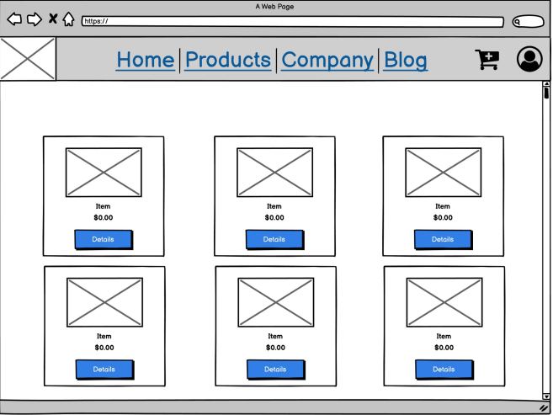

Figure 59: Admin Console Wireframe

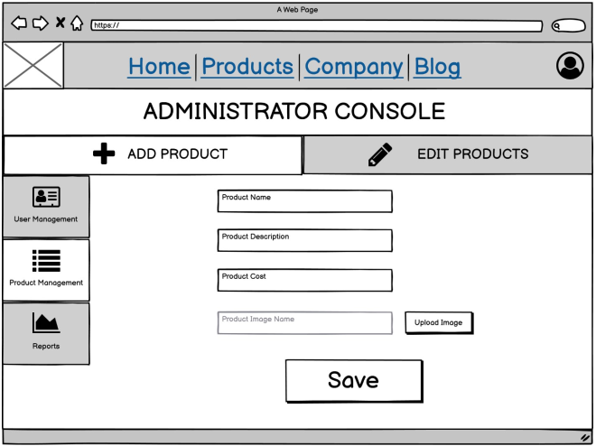

## APPENDIX D: Chatbot Models

The many chatbot models all include analysing input and developing response mechanisms. The following list of chatbot models includes:

**Retrieval-Based -** This paradigm is more adaptable since it searches and analyses resources via APIs. In reality, a retrieval-based chatbot must obtain a number of answer options from an index before selecting a response using the matching approach.

**Rule-Based -** According to the input text, this model selects answers based on a specified set of rules. To determine context and select a response based on a human-hand-coded knowledge base, the input text is analysed lexically. This model has the limitation that it can only choose replies in a single-turn discussion while taking the most recent input message into account. This robotic method does not produce answers that are pertinent to the entire dialogue.

**Template-Based -** This approach provides replies based on the discussion history using AIML templates. Due to the AIML templates' reuse of the user's input in responses, this paradigm has the disadvantage of producing inaccurate phrases. In order to guarantee that the chatbot provides accurate sentences, string-based criteria are used.

**Task-Based -** This type carries out particular duties like making hotel or travel reservations. This model can comprehend users' related input and is the most accurate in a certain field and context.

## APPENDIX E: Comparing Agile and Waterfall Methodologies

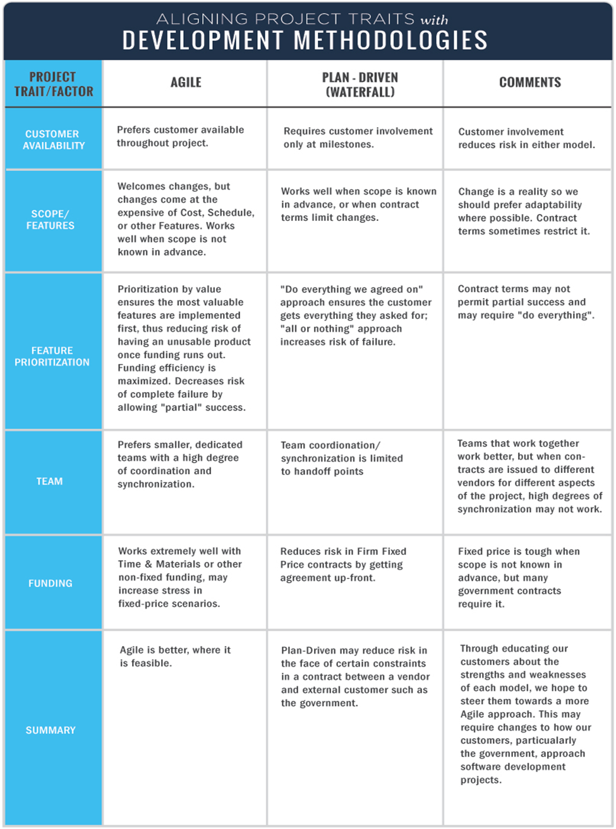Appendix E: Comparison of Software Development Methodologies Source: Segue Technologies(2018)

## APPENDIX F: Programming Language Comparison

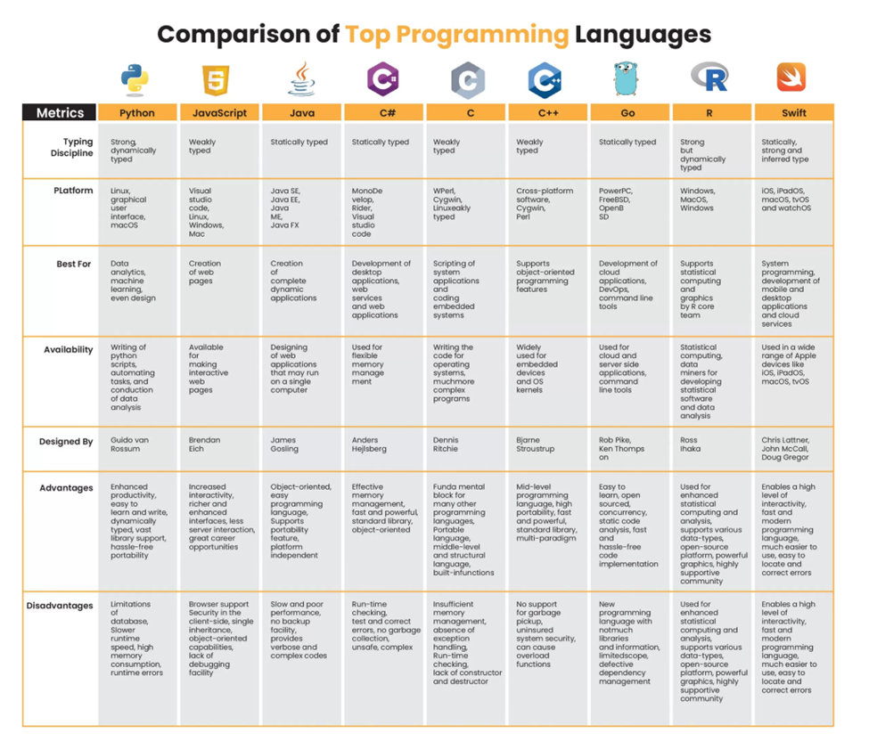Appendix F: Comparison of Programming Languages Source: ISHIR (2021)

## APPENDIX *G*: Poster

